Contents

NOTE: 2

Links 3

Introduction 3

Installation 3

Getting Started with Python 8

Variables 10

List 13

Tuple 16

Set 17

Dictionary 17

Set Path in Windows & Help 19

Help 23

Python Editor 25

More on Variables 26

Data Types 28

**Pending** 32

Import Math Functions 32

Working with PyCharm 34

User Input 41

If Elif Else Statements 49

While Loop 53

FOR loop 56

Break Continue Pass 59

Printing Patterns 61

FOR Else 63

Functions 65

Function Arguments 67

Types of Arguments 68

Keyword Variable Length Argument 70

Global keyword 71

Decorators 74

Modules 75

Special variable__name__ 77

Object Oriented Programming 79

Class and Object 79

__init__ 83

Constructor, Self and Comparing Objects 87

Types of Variables 90

Types of Methods 91

Inner Class 95

Inheritance 96

# NOTE:

1. Python uses Dynamic Typing (You can reassign variables to different data types & no error is thrown). This makes python flexible in assigning data types, this is different than other languages that are “Statically-typed”

Example: my_dogs= 2 and also my_dogs=[“Sammy”,”tommy”]

1. To use argv argument function, we need to import sys
2. An IDE will use indentation (spaces in front of the statement inside the loop) by default
3. In 2 loops, “i” represents number of rows and “j” represents number of columns. Number of columns depend on the row number.
4. For & Else loops can be integrated together in python unlike other languages
5. Always good to have separate function for a separate task
6. Despite being neither a pass-by-reference language nor a pass-by-value language, Python suffers no shortcomings in that regard. Its flexibility more than meets the challenge
7. Preferable will always be given to local variable instead of global variable
8. Global variables can be access even inside a function, but local variable cannot be accessed outside its scope/function.
9. Python is a functional programming language where we can define function inside a function
10. Python supports all 3 programming – Object oriented, Functional & Procedure oriented
11. Procedure - Procedure-oriented languages (POLs) are artificial languages used to define, in a form understandable to humans, the actions required by a computer to solve a problem
12. Functional – You can achieve a task implementing functions as a mathematical function where we will not manipulate a data like decorators
13. Oops – We solve real world problems using virtual software right, and we need objects for everything like phone is an object, laptop, bag everything is an object required to do something. An employee also is an object who needs laptop object.
14. In a dictionary, all keys must be unique.

Why use curly brackets for dictionary? Even sets use curly braces & sets are having unique values & hence curly braces are common to both.

# Links

1. Youtube link: <https://www.youtube.com/watch?v=QXeEoD0pB3E&list=PLsyeobzWxl7poL9JTVyndKe62ieoN-MZ3&index=1>
2. Theory notes: <https://docs.python.org/3.11/tutorial/>
3. Github link to download resource: https://github.com/Pierian-Data/Complete-Python-3-Bootcamp
4. Basic practice: <https://codingbat.com/python>
5. Mathematical/harder practice: <https://projecteuler.net/archives>
6. Practice problems: <http://www.codeabbey.com/index/task_list>
7. **A SubReddit Devoted to Daily Practice Problems:** <https://www.reddit.com/r/dailyprogrammer>
8. **A very tricky website with very few hints and touch problems (Not for beginners but still interesting):** <http://www.pythonchallenge.com/>
9. **Certificate learning:** <https://pythoninstitute.org/python-essentials-1>

# Introduction

Python is the fastest growing language in terms of

1. Number of developers who are using it.
2. Number of libraries it has
3. Number of companies which are using this language.
4. Number of areas where we can use like ML, GUI, Software development, web development etc.

And that’s why it is also called as **General-purpose language.**

Python is Interpreted, Object-oriented & High-level language. It supports procedural read programming as well as object oriented.

Python came to picture in 1989 whereas JAVA came in 1995.

Now since the advancement of ML, AI, this is the field where research scientists don’t want to spend much time on programming language so check for the easiest language available in the market.

**Python versions:**

1. Python 1.0 – January 1994
2. Python 2.0 – October 2000
3. Python 3.0 – December 2008

2.x version is still in the market (has support till 2020) because it is completely different than how 3.x works.

# Installation

We need to use editor to write the code (like notepad, notepad++, atom or sublime)

As python is an interpreted language, we need to install python interpreter which converts our code to a binary code. Go to Google & navigate to the official website.

When we are building complex projects, we will be using IDE -> Integrated Development Environment (a place where we write our code, debug it & run it)

We need 2 things -> Interpreter & IDE

PyCharm is the best IDE available (developed by Jet brains) For java we have IntelliJ ide.

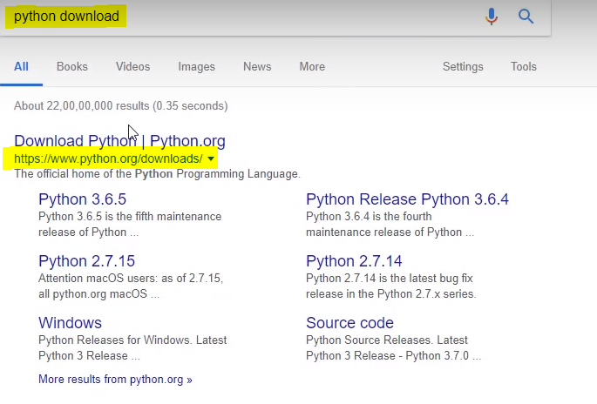

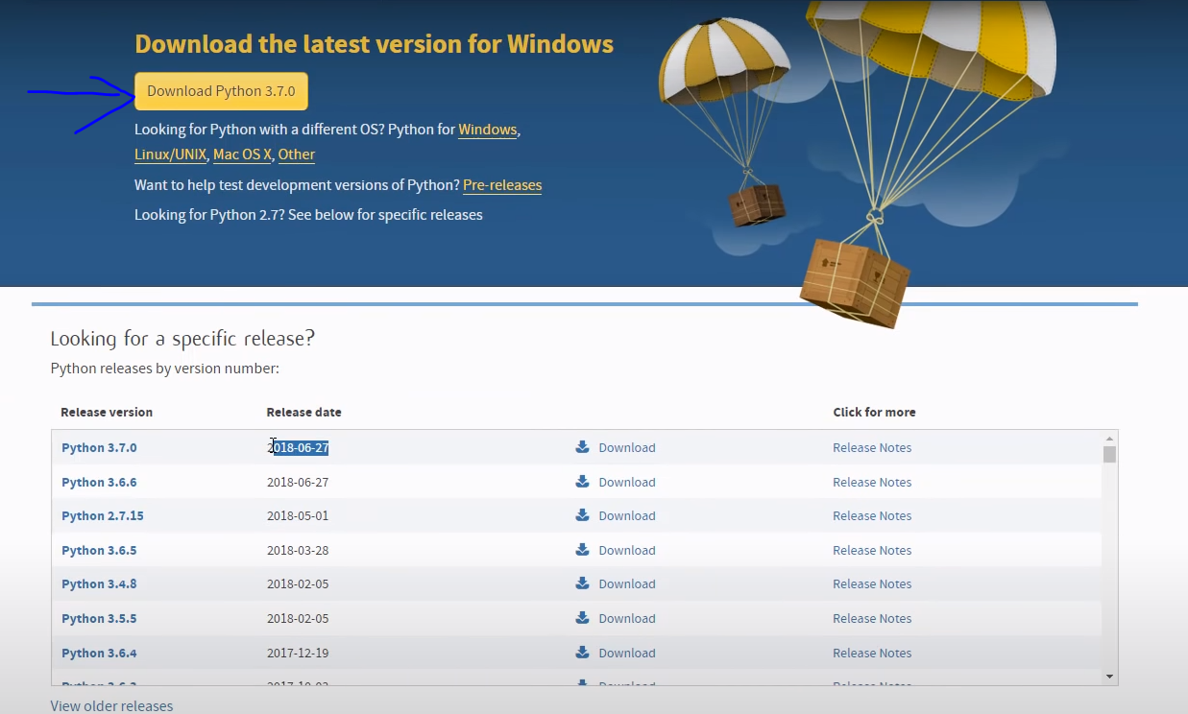

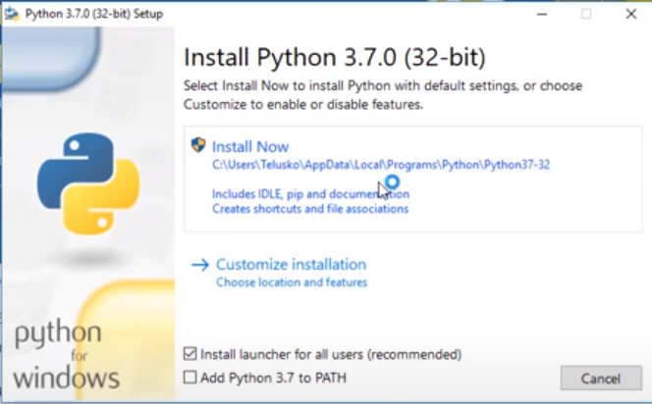

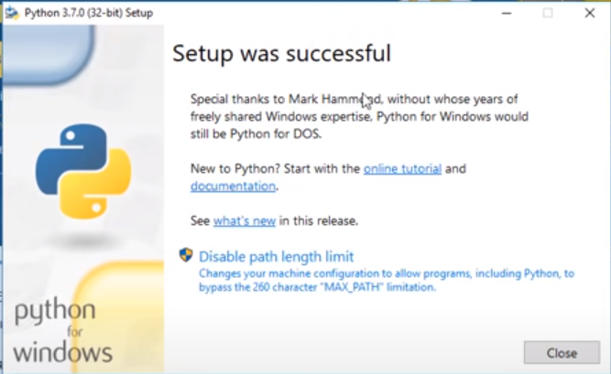

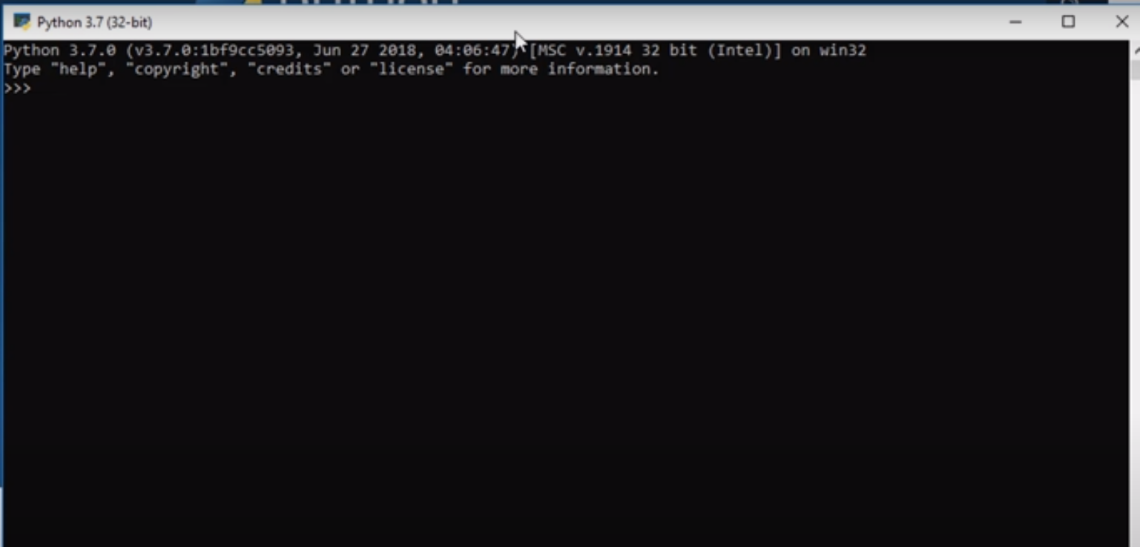

In windows we call it as prompt, in Linux we call it as shell.

Checking if the Interpreter installation works

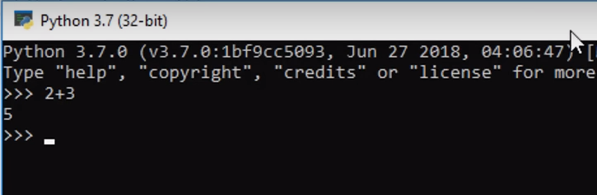

Yes, it’s working, now we need to install IDE PyCharm

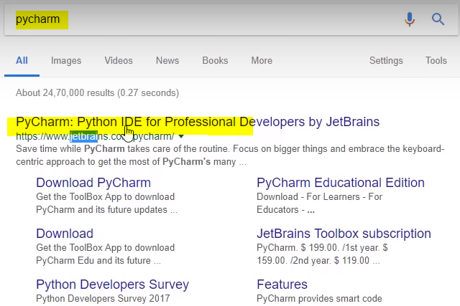



We have 2 versions here: Professional & Community version



Choose the path & install

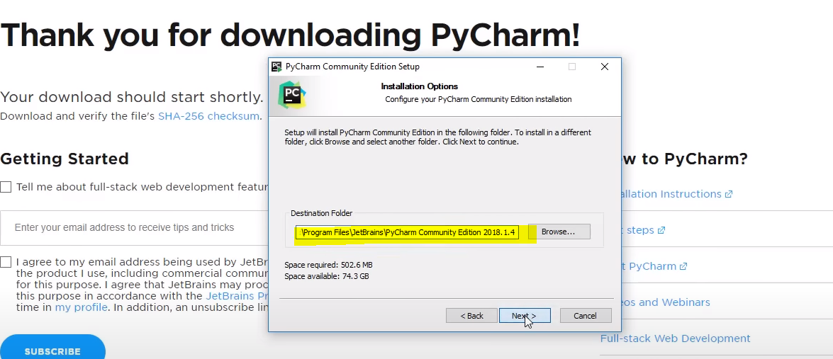

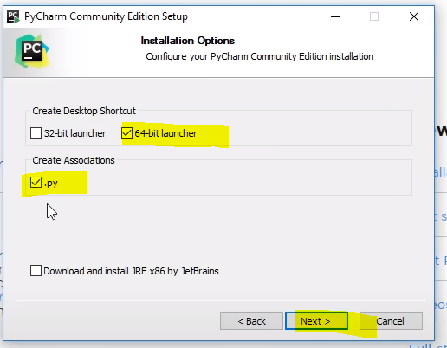

Below is how PyCharm looks

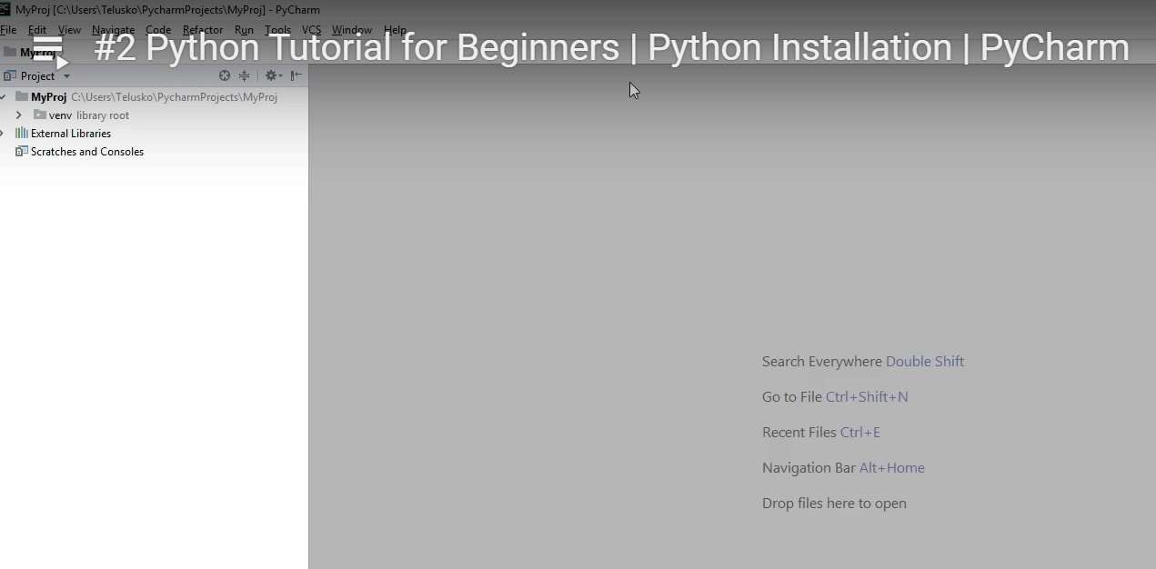

# Getting Started with Python

You can understand English and so you will learn a programming language and write a code. This code will get converted to binary code which will be understood by the computer.

We can simple arithmetic operations like below. We can also use string operations & certain functions like print

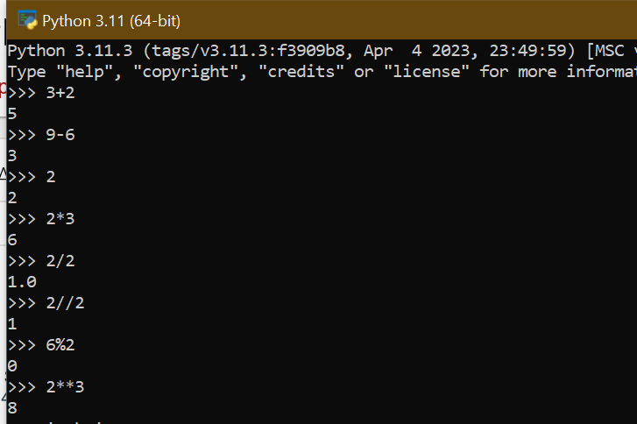

Function is nothing but a set of tasks which we need to call it. A normal ‘achu’ output is different than what we called inside function like below

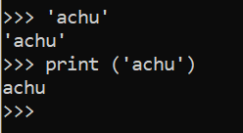

We just cannot use the quotes everywhere like below

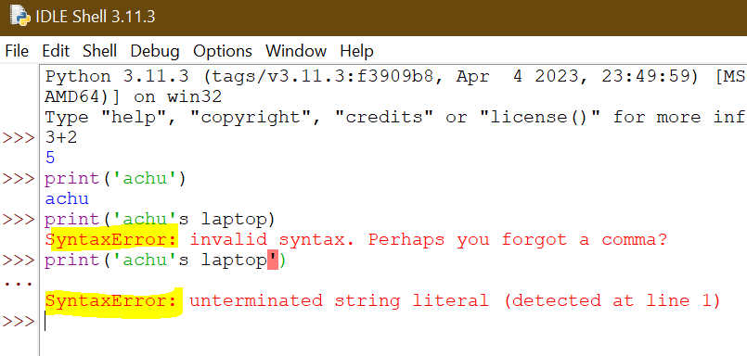

Above can be solved in 2 ways.

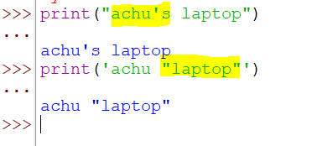

But what if we have both in our string

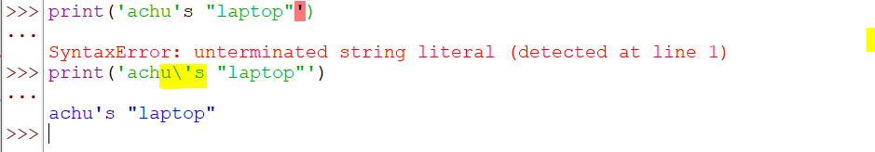

We can also perform string concatenations in the below ways

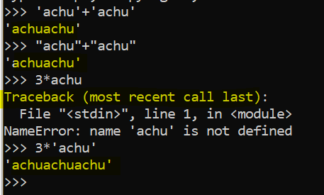

How to avoid this special meaning terms in python \n. It is treated as a new line & giving below output

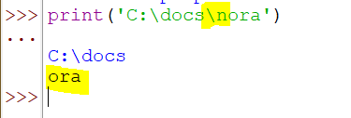

To handle the above, we can use a function called “**Raw string**” which types the string as it is like below

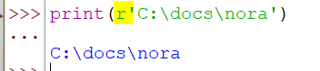

# Variables

Variable is a container where we store the values. The term variable means “changing”. We can change the variable value at any point and the latest assign value will be stored in it. Variable must be initialized by assigning it a value. If we do not initialize and try to call it in our operation, it throws error.

**Rules:**

1. Variable names cannot start with a number
2. There can be no spaces in name, instead use _
3. Can’t use special characters
4. Avoid using names of inbuilt methods or functions
5. It is best to have names in lowercase

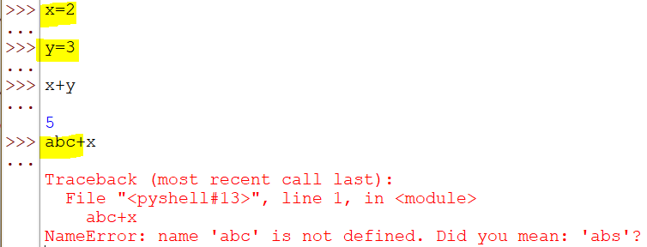

We can use the previous output in our next operation by using “_”

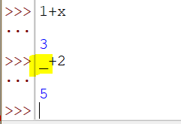

When we want to fetch any character in a string, we need to call the array index as the string characters are seen in the form of array.

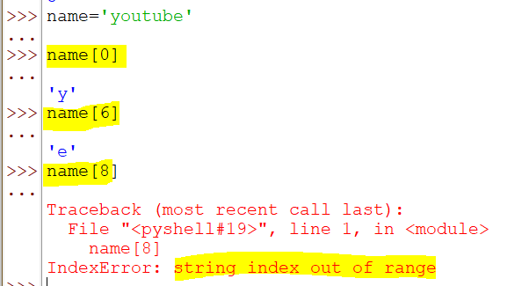

What happens when we use negative numbers as index of the array? It starts counting from the right side of the string that is from end to start

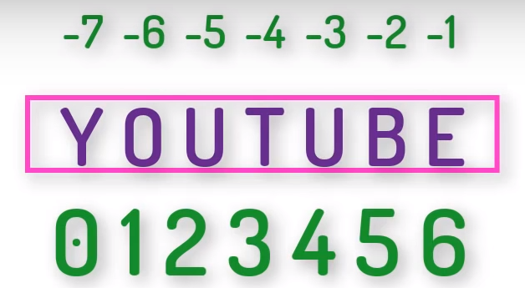

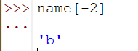

When we want to print 2 characters, we use the syntax **Variable[Start Index : Last Index].**

If we don’t specify the last index, it gives us the full length

If we specify last index, but not 1st index, then it will start from initial character till the provided length

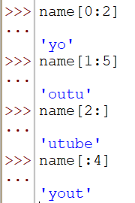

If I give the length out of range along with CORRECT index, it doesn’t throw error, but prints till end as the index is beyond the end index

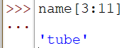

What if we want to change the word from YOUTUBE to MYTUBE

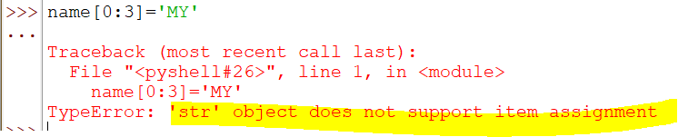

Once we assign the characters, we cannot change it again, not even a single character like below

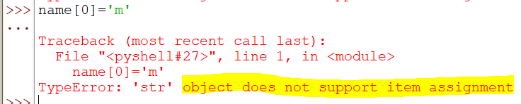

***It means Strings in Python is IMMUTABLE***

We can do a workaround like this if you want to print mytube

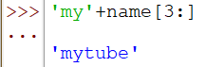

If you want to know the length, we can use inbuilt function. This counts even space

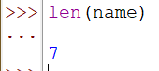

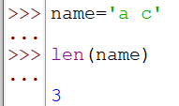

# List

List is used to store collection of data of **multiple data types**. List is **MUTABLE** (values can be changed) and is stored in **[] SQUARE brackets**. Lists are one of 4 built-in data types in Python used to store collections of data, the other 3 are Tuple, Set, and Dictionary, all with different qualities and usage.

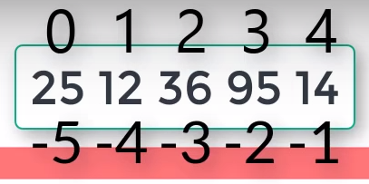

Initialize and get values like below

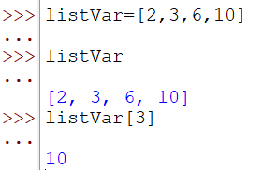

We can call index like below

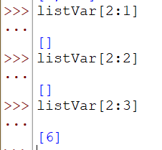

We can use 2 different lists and perform operations like below

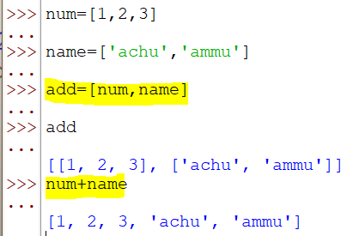

There are several functions which can be used in lists like below

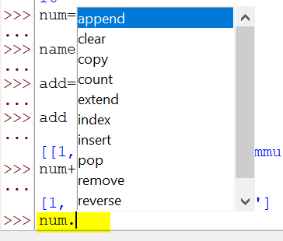

Below is the append function

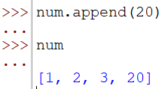

Append will add the value at the last whereas Insert will add at the index we want

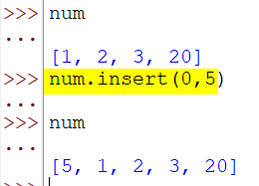

Remove will remove the item by specifying the number/value whereas pop will ask the index

Pop without any index value will remove the last value

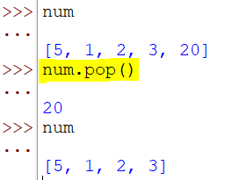

Del is a function to delete the items in list

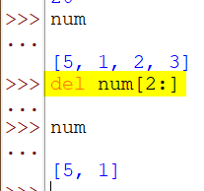

Add multiple values to list

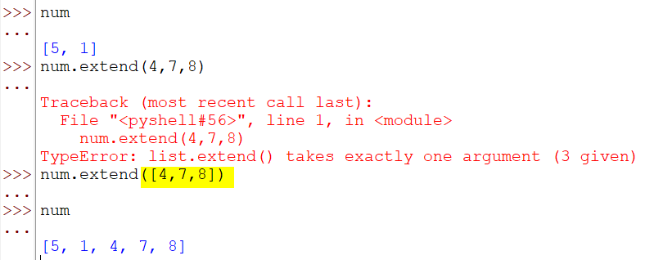

Perform operations like below using functions

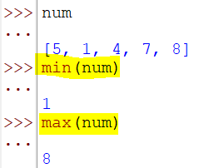

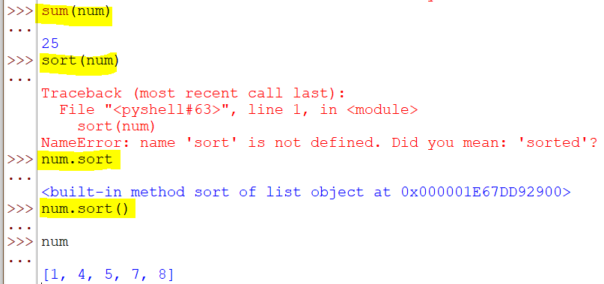

# Tuple

Tuple is same as List but **IMMUTABLE** (values cannot be changed) and are stored inside **() COMMON Bracket**. Since the values are fixed here, ***iterations are faster*** in tuple than in list.

Tuple is used where project has a requirement whose values will remain idle without being changed.

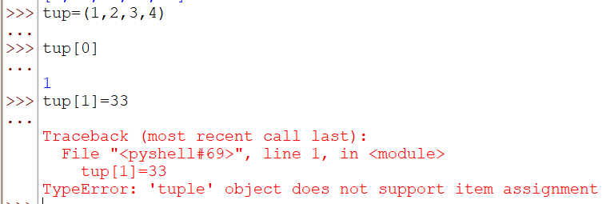

We have only 2 methods for tuple like below. We can clearly see that there are no methods to append or delete.

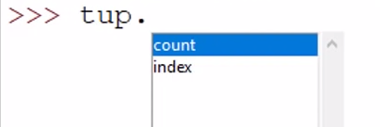

# Set

Set is a collection of unique elements which use **{} FLOWER bracket**

Set will not follow a sequence in which you have created/stored the elements.

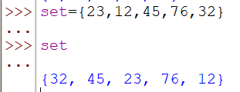

Speed works more than the sequence here. Since we do not have proper sequence here, index will not be set

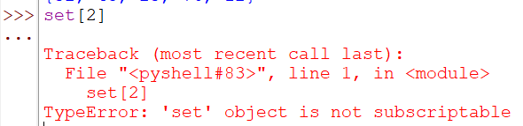

# Dictionary

It is used to store data as collection in the form of key value pair. Keys are immutable here (cannot change key). **{} FLOWER bracket** is used

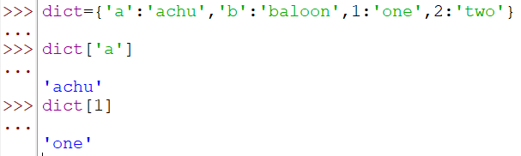

We can also

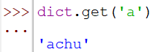

Different method is giving different output

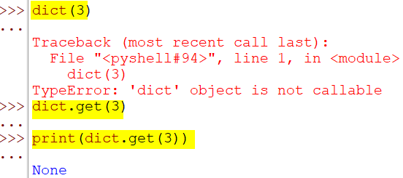

If you search for some value using the key & when it doesn’t have any value, instead of throwing error, you want to throw a message saying, “no such key found”, do the below

**dict.get(*index*,’no such key found’)**

Here there is a key ‘1’ and hence it returns value but there is no key called ‘3’ and hence it returns the message given by you

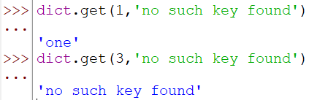

Let’s create dictionary using 2 lists

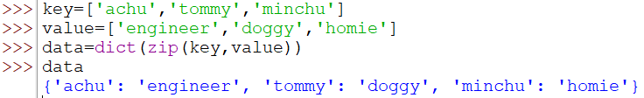

Assign value to dictionary



If we want to delete the key

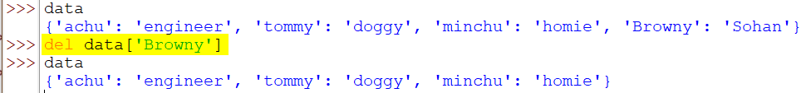

We can create List & Dictionary inside a dictionary like below

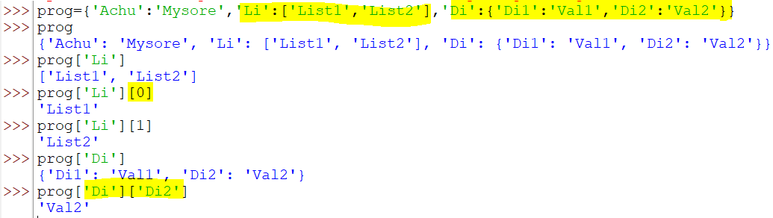

# Set Path in Windows & Help

Till now we are using IDLE as our IDE but what if you want to use shell or command prompt. When we try to open python using cmd just by typing python, it will not be able to recognize

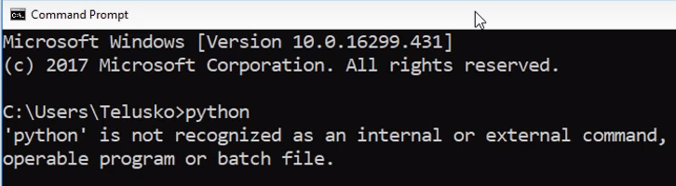

Python is installed somewhere in C drive & cmd can’t get the path of it. So, we need to specify it by ourselves. Even if we set path, it will be a temporary setting as the path will be lost when we close & open cmd

Go to C drive on your machine, right click on the screen & click Properties

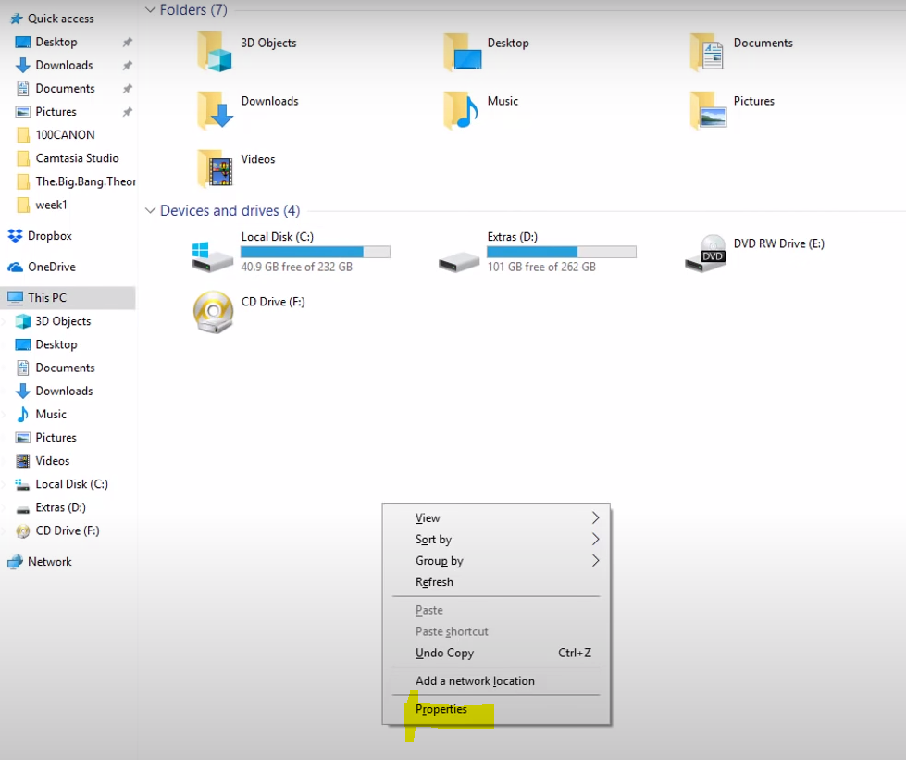

Click on Advance system settings

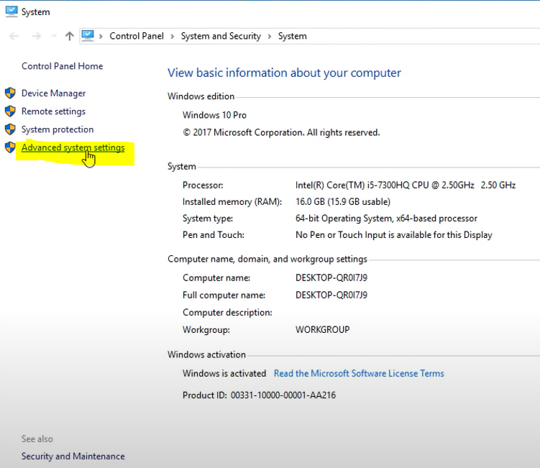

Click on Environment variables

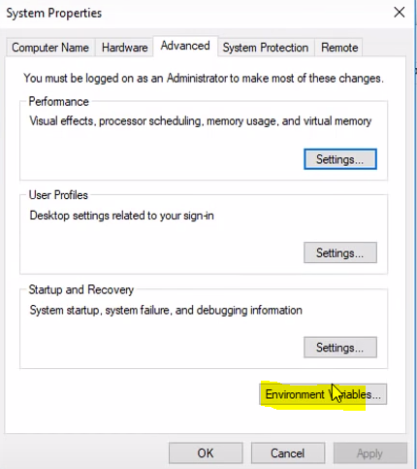

Double click on Path

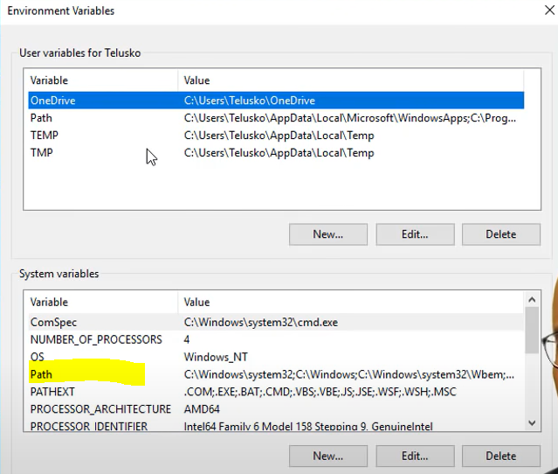

In this prompt you need to add the path

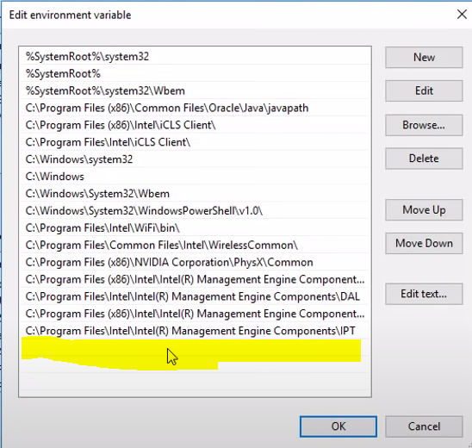

Copy this path where python is located & add in the above prompt

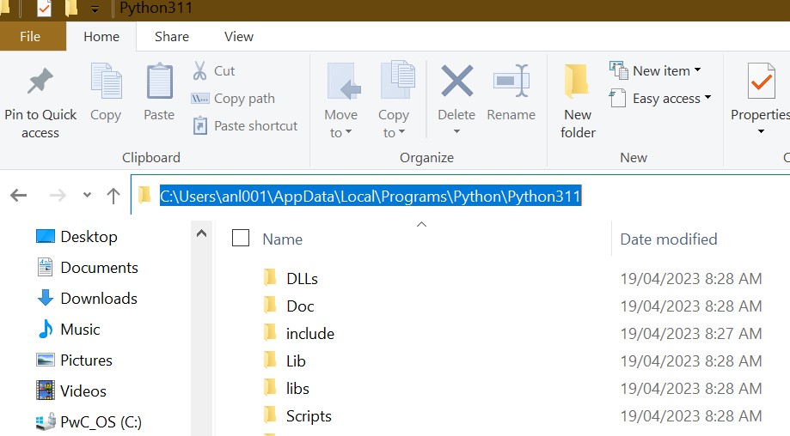

Copy the below 2nd path and place it in the prompt

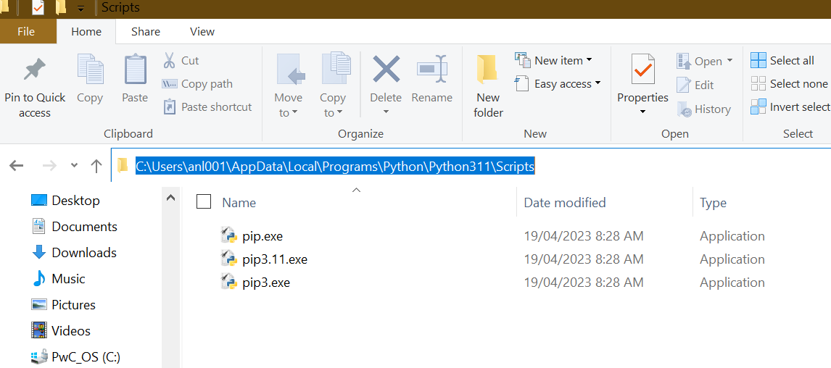

Now the prompt looks like this with both the paths placed in it, click on New and paste

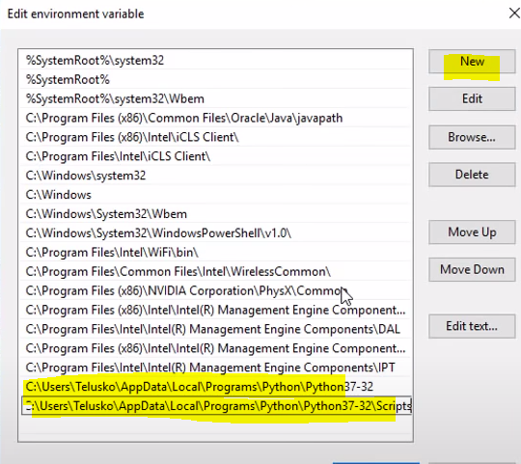

By doing this we have set the path. Restart your cmd and check for python now with the operations being recognized

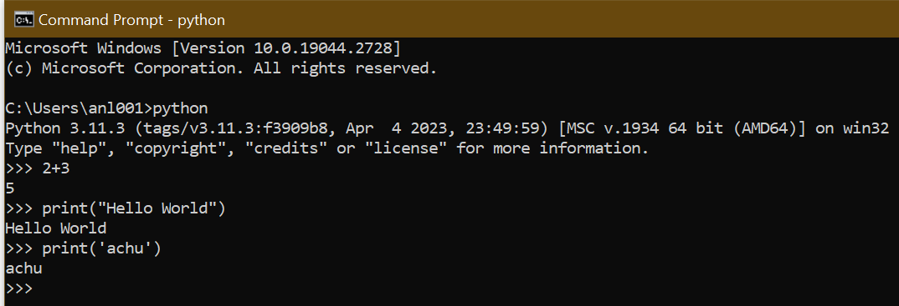

# Help

We can make use of help like below

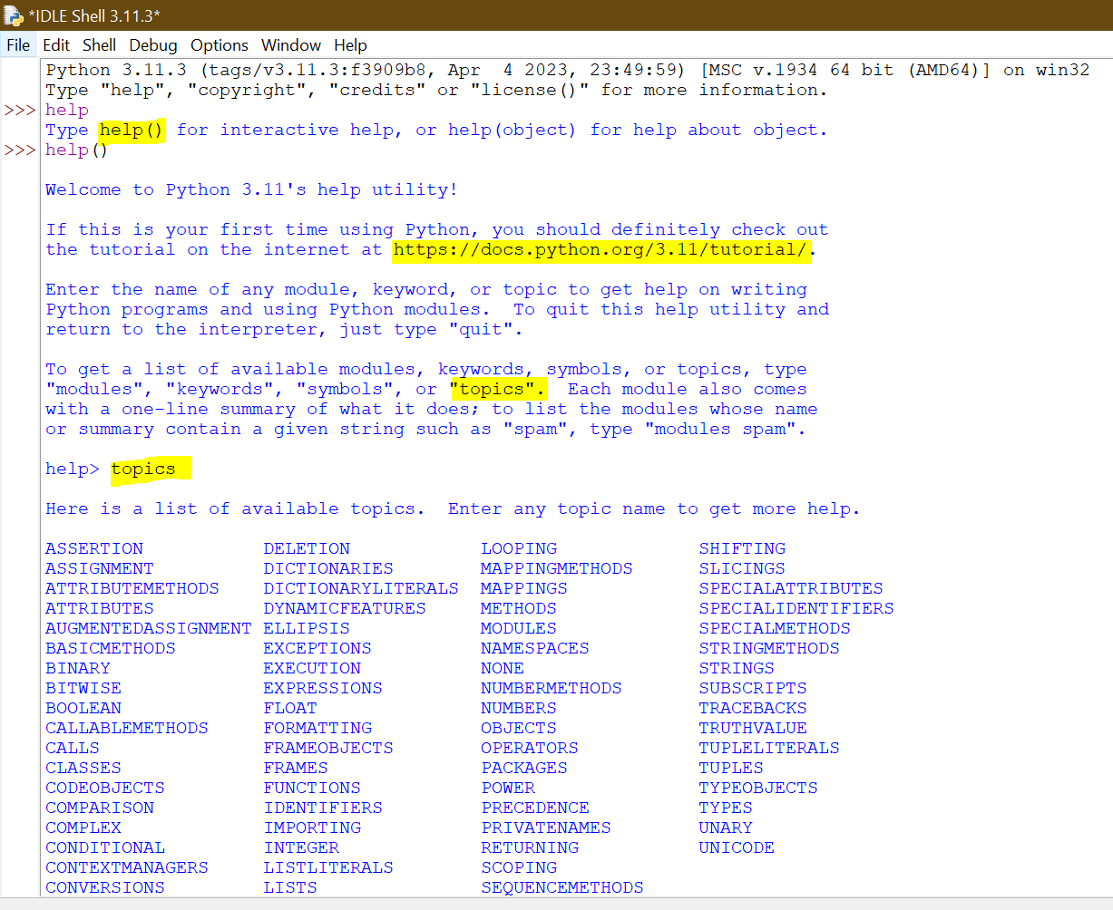

If we write LISTS in help, it helps us with the information about LISTS

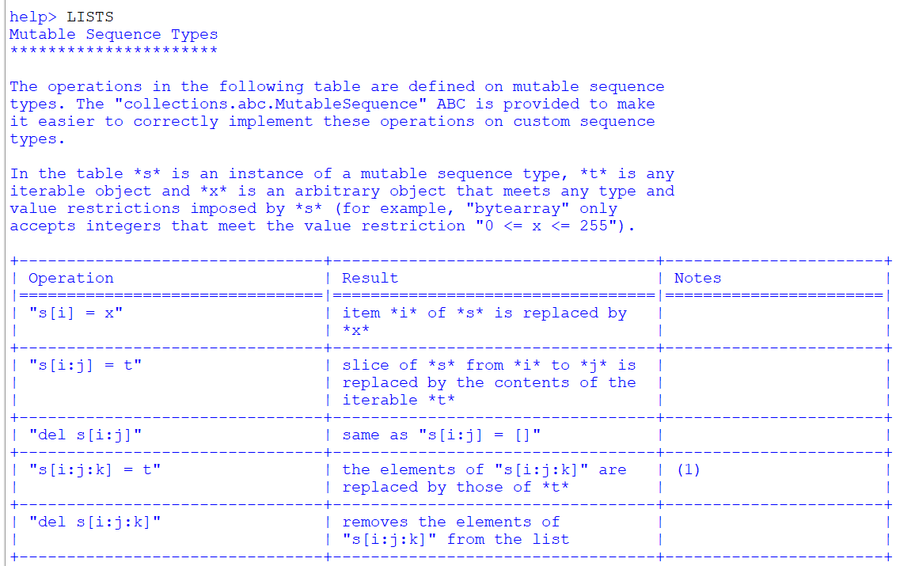

We can simply type help(‘LISTS’) to get information about LISTS

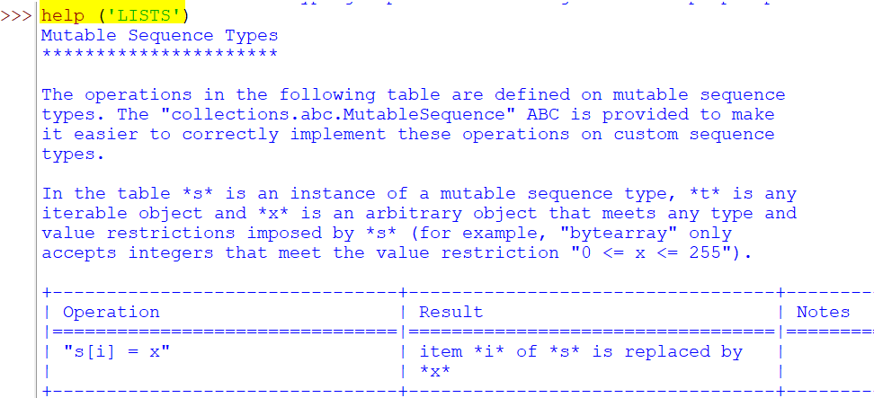

# Python Editor

We can also use Sublime instead of Pycharm. Sublime looks like below

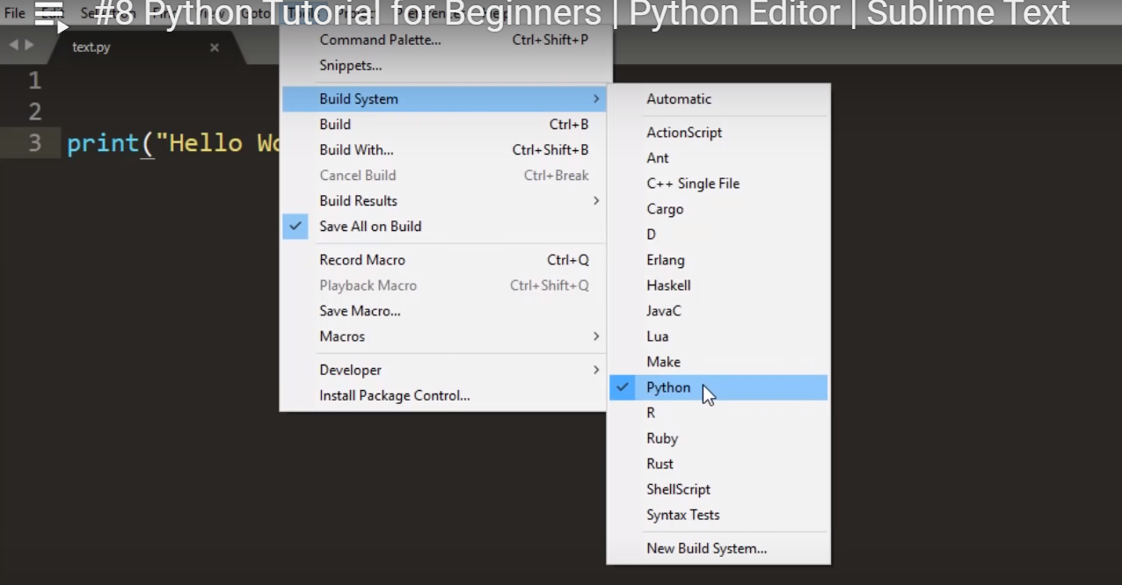

Control+V gives the output

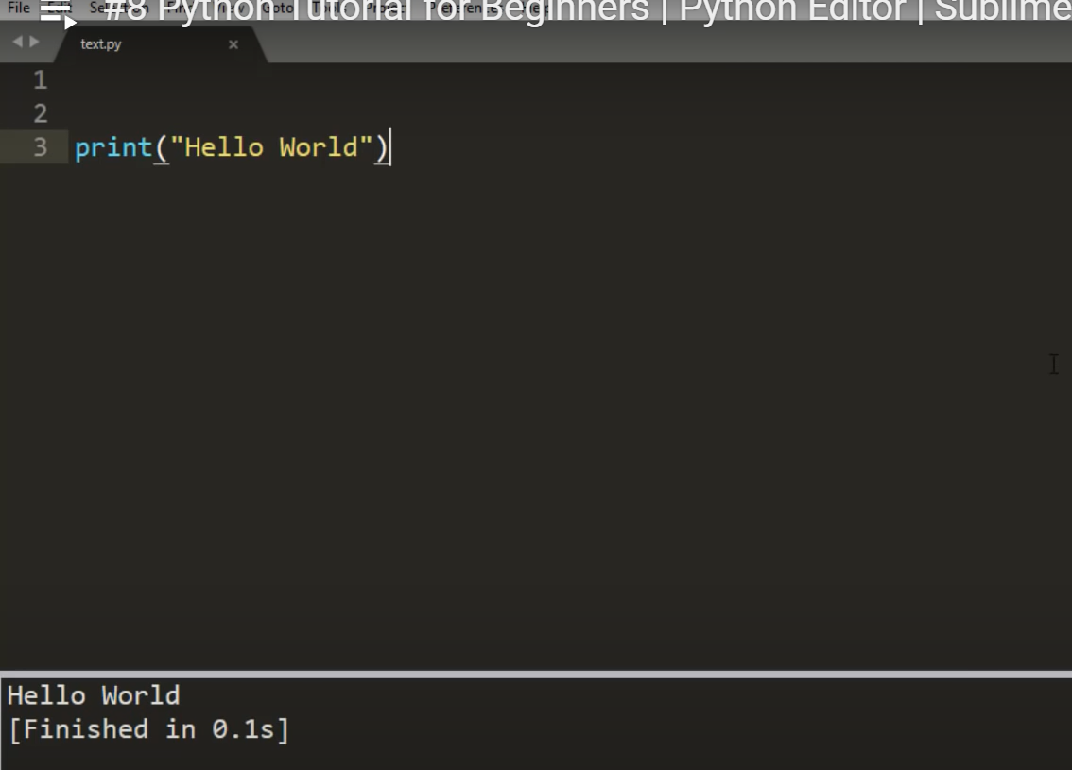

# More on Variables

Whenever we create a variable, a box with name will be created and whatever value you assign will sit in the box and it will also have address

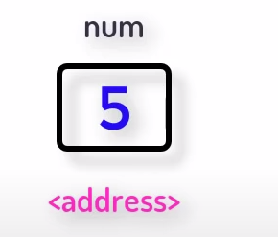 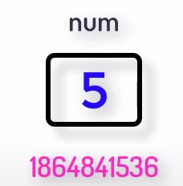

To find the address we use a **function id.** Different variables have different address

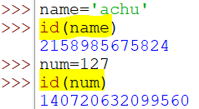

Let’s assign a value to 2 variables & check if both the variables have same address as the value is same

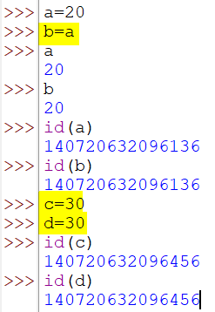

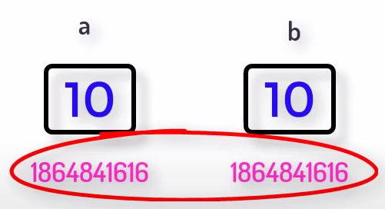

**This is how Python is more memory efficient**

We can check the address not only using the variable name but also its value

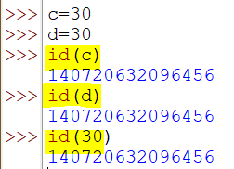

Variable is like a tag here as we are tagging a value to various keys

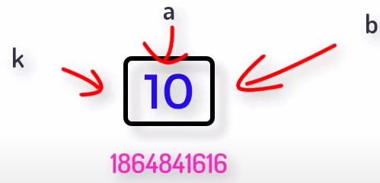

If we change the value of a variable tagged to another variable, then what happens?

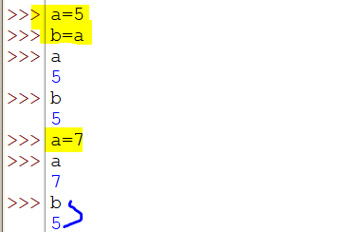

When we change the variable values and a box having a value which was previously assigned to this variable still exist, the concept of **garbage collection** arise.

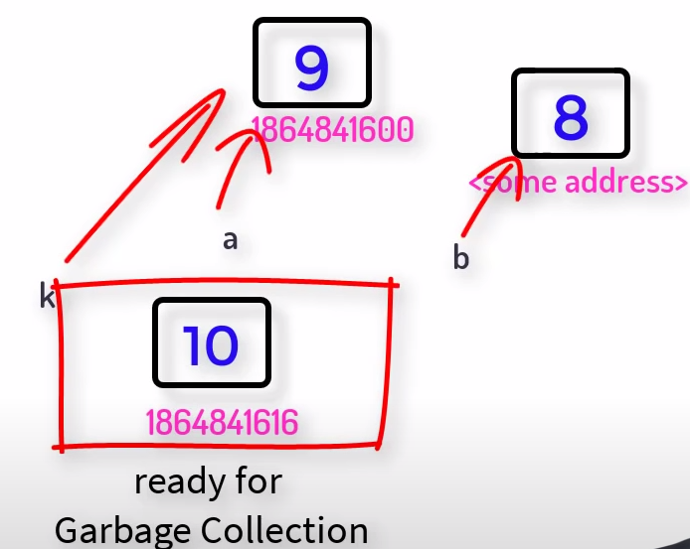

**Variables cannot be made Constants in python but you can show your intention by creating a variable in CAPITAL letter stating that this will be behaving like a constant and no one should change its value.** If we want to know the type of the variable, use method called type as below.

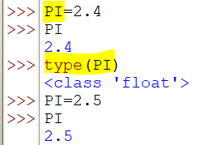

# Data Types

There are many data types in python like below

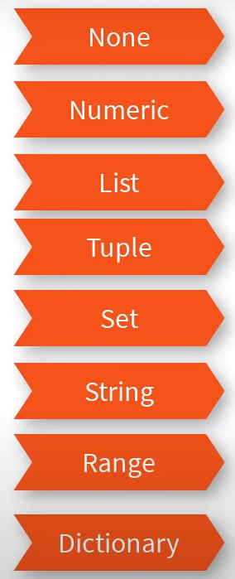

When you have a variable not assigned to any value, it is NONE. In other languages it is called NULL.

In Numeric we have int, float, complex, bool.

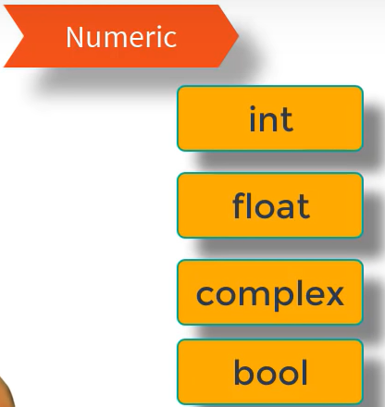

Below j is square root of -1

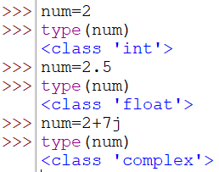

Converting float to int

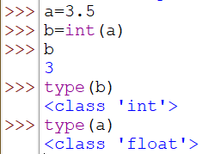

Converting int to float

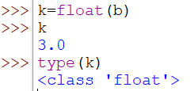

Converting to complex, we can pass either 1 variable or 2 as below

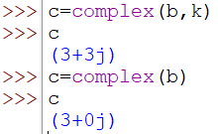

Bool is nothing but TRUE or FALSE

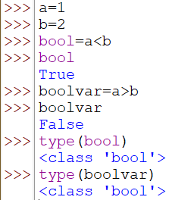

Converting Bool to number/integer

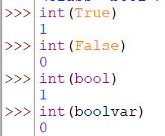

Other types are

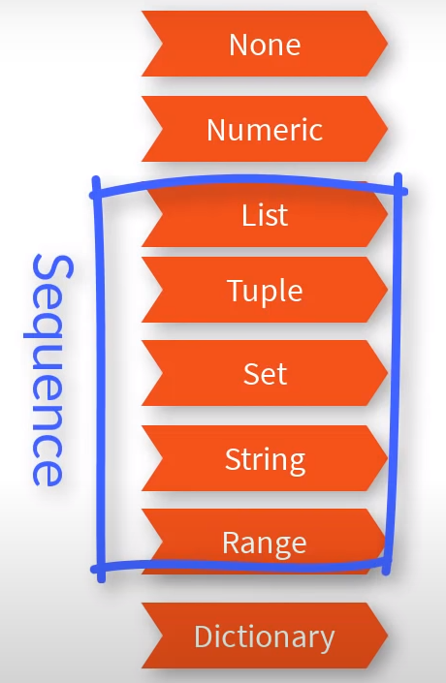

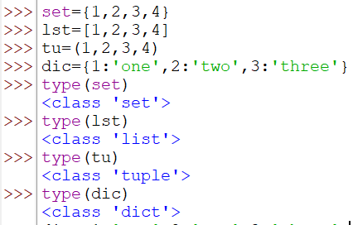

There is no type called “character” as such in python. Even a single character is treated as string

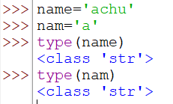

We have a fancy stuff called “Range” in python but not in other languages. Converting Range to List to see the values in it

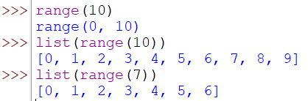

To print all even numbers in a range or print a difference between numbers

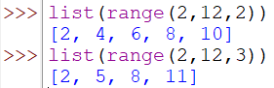

Know the type of range like below

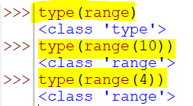

In a dictionary, all keys must be unique.

Why use curly brackets for dictionary? Even sets use curly braces & sets are having unique values & hence curly braces are common to both.

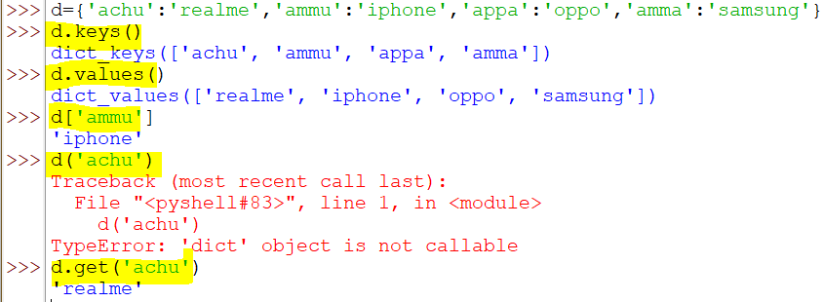

# **Pending**

# Import Math Functions

When we want to perform any mathematical operation, instead of we writing the expressions, we can just call the mathematical function/method and it does everything you want

But this gives error

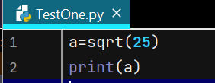 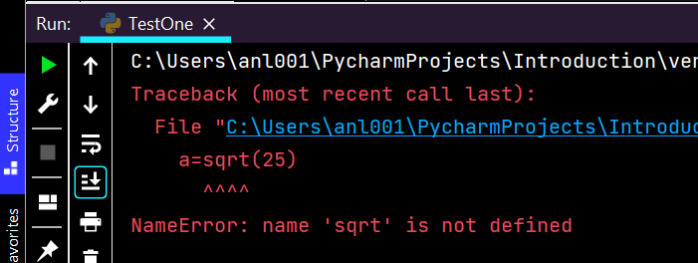

It says “sqrt” is not defined. To define, this is not a variable, this is a method. But to use this, we need to import its specific package

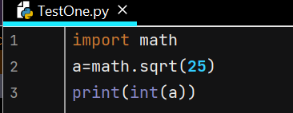

But when you want the integer part rounding off, we use **CEIL & FLOOR** concept.

***Ceil – rounds off a number to the above one***

***Floor – rounds off a number to a below one***

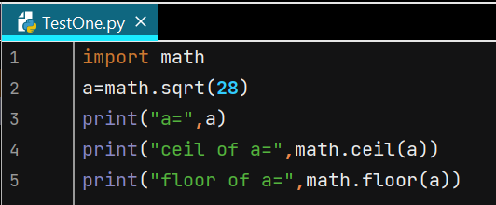

Output is:

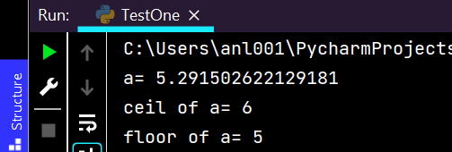

When we work on big projects, we can’t keep on using math instead we need to do something like use single character ‘m’. For that we need to define the alias.

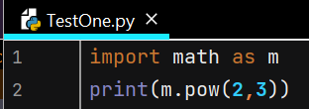

When you import math, we get every method of it. But what if we need only few functions like power or factorial. When you import only 1 function from math & try to use another, below is the output

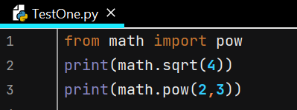 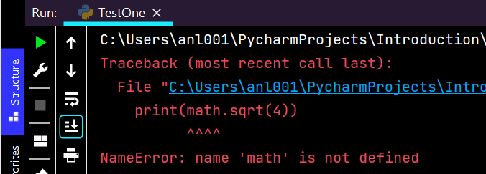

To use both the functions, use below

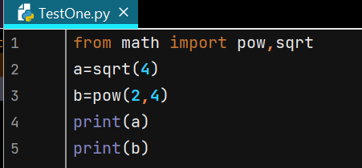

Output:

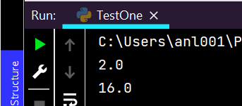

# Working with PyCharm

Once we create project it will appear in the left side like this, we need to create a python file inside this project like below

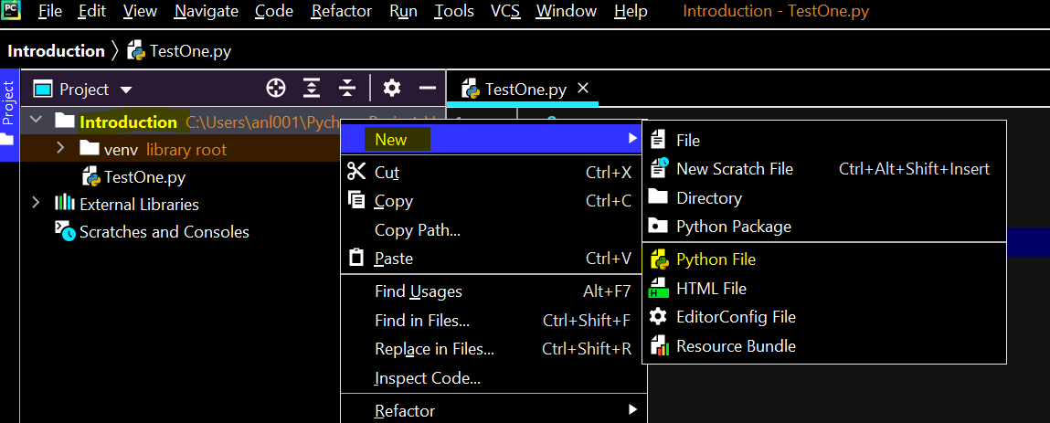

Once we create project Python file, it will appear in the right where we can write or paste our code

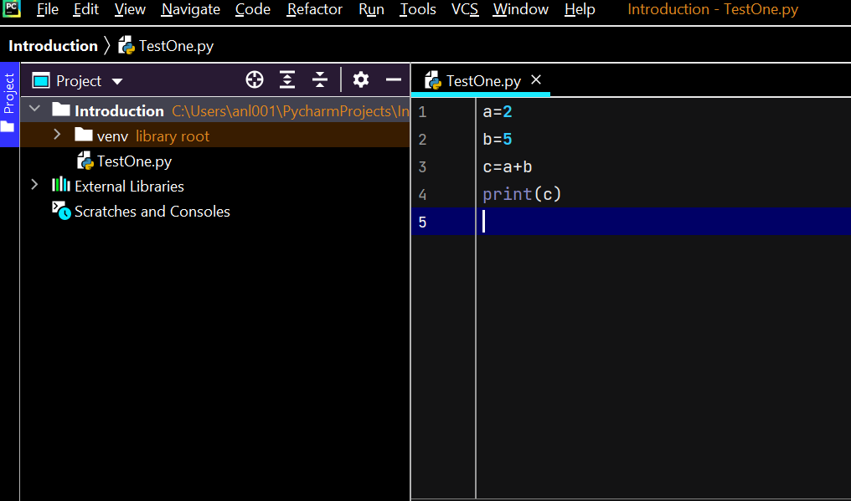

There are 2 ways to run the code on pycharm.

1. Using Run button in the menu bar like below 1st image

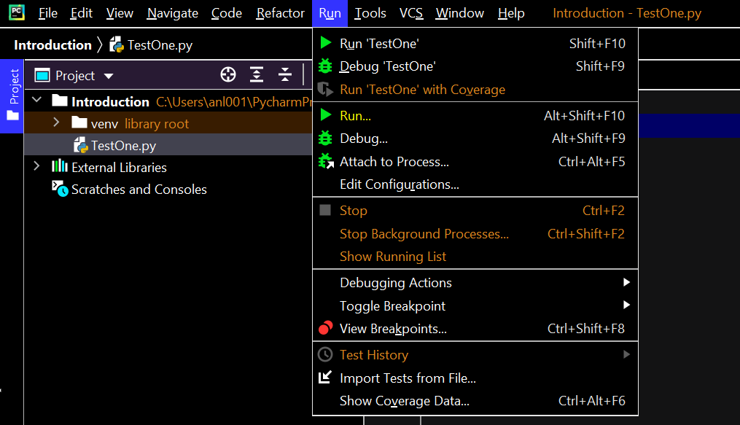

1. Right clicking on the code screen & clicking on run as like below 2nd image

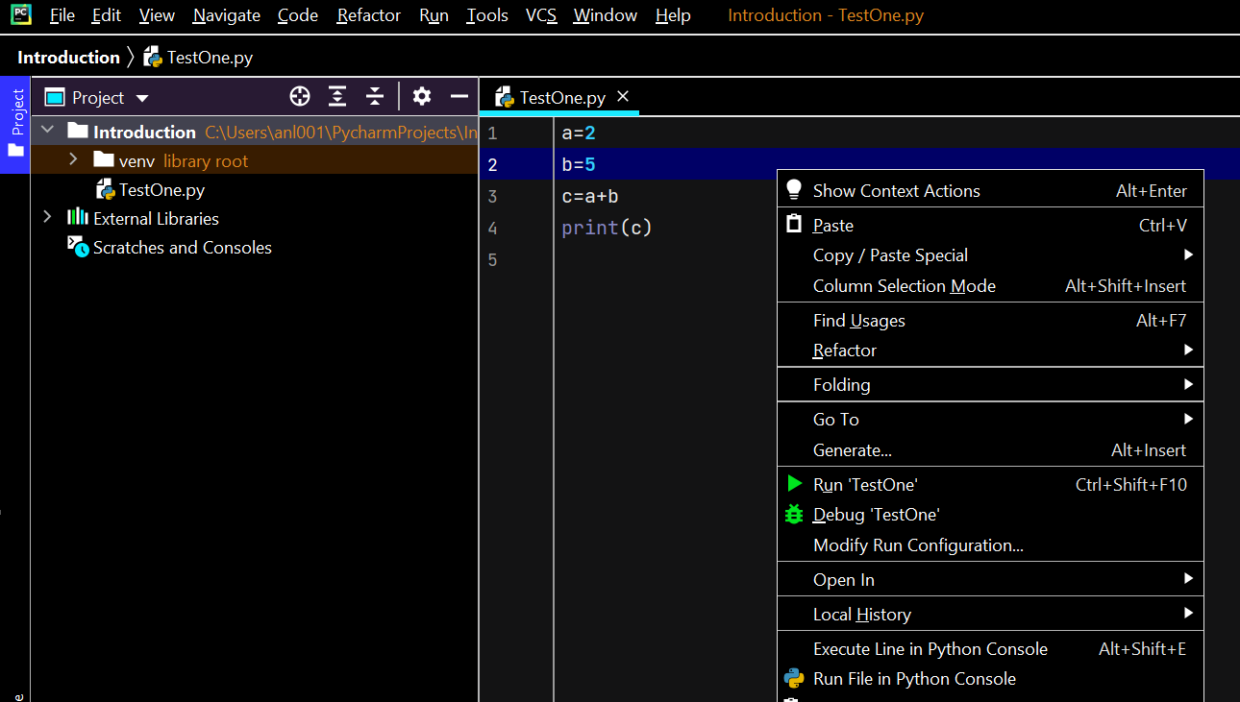

We can watch the output in the downside menu. If code is Run, the output will be in Run section

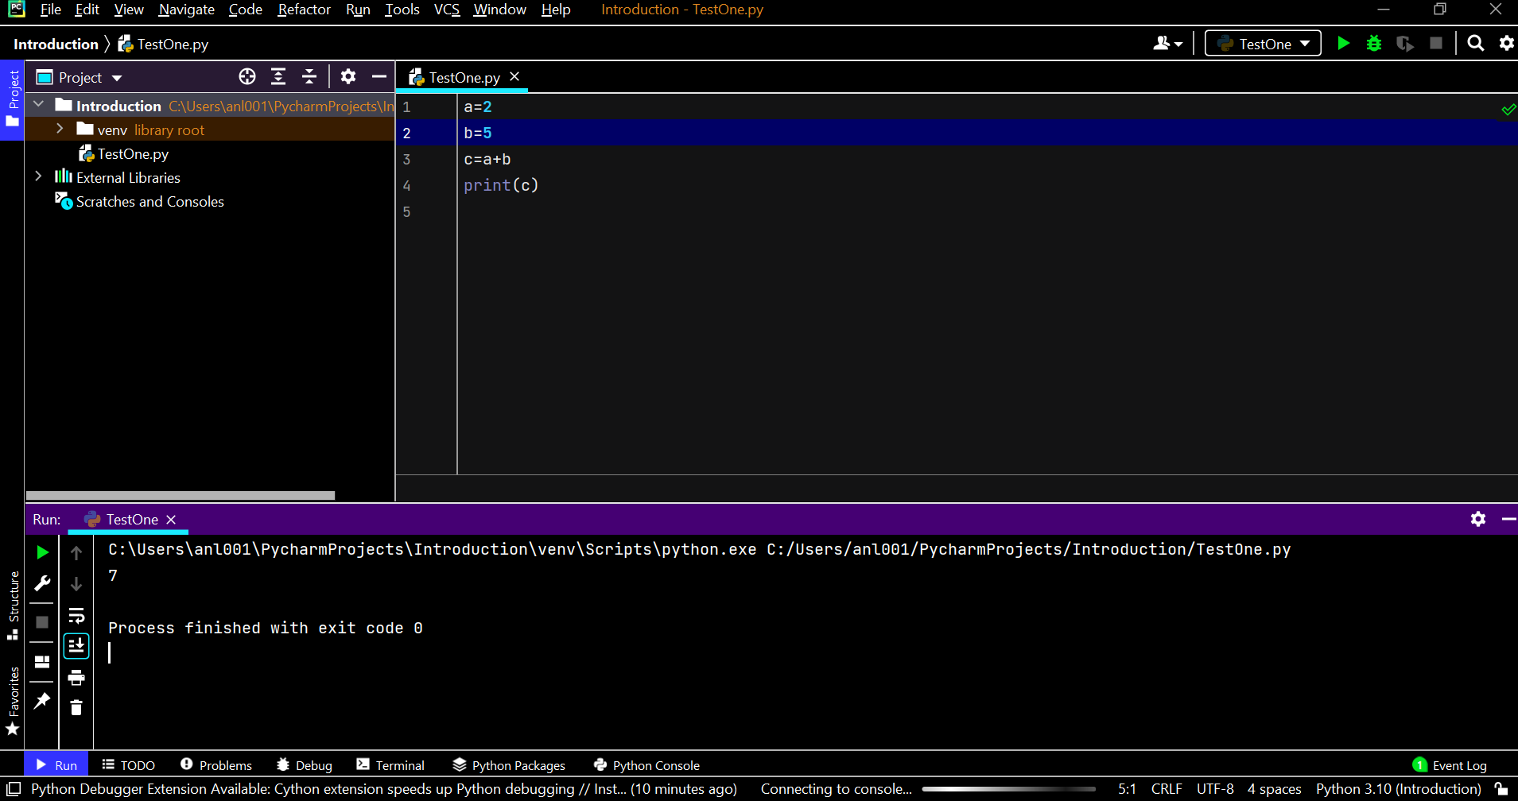

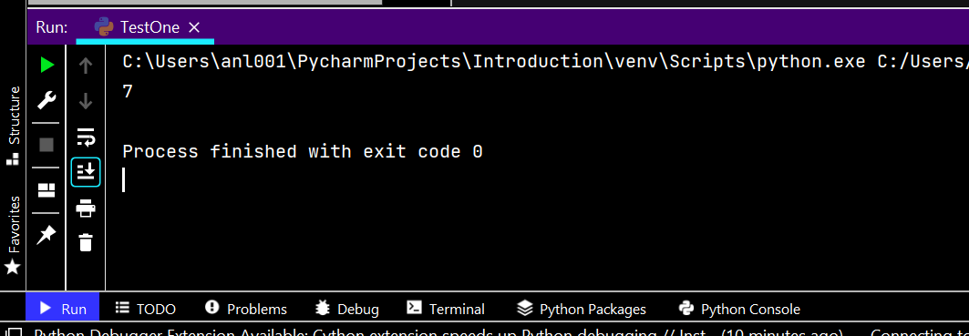

If code is debugged, output will be in debug section

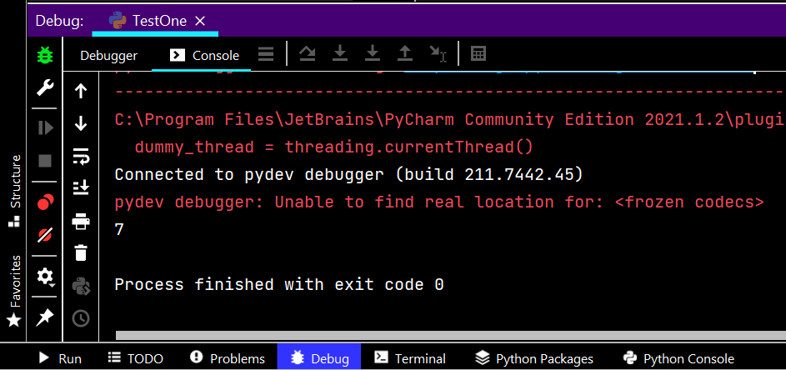

If you want to change the value in the code & re-run then the button in the output section can be used

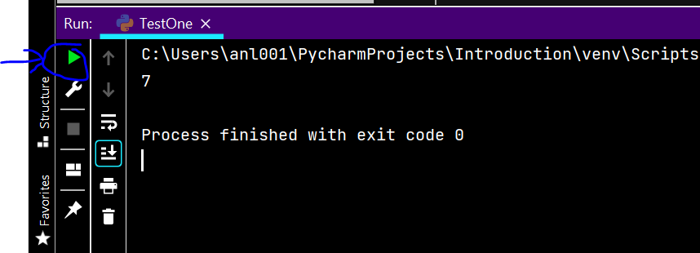

Debug is nothing but tracing the execution for a better understanding. We can place breakpoint by just clicking on the line & click on debug. Below will be the execution result

Debug section will have 2 subsections – Debugger & Console

Debugger section looks like this once

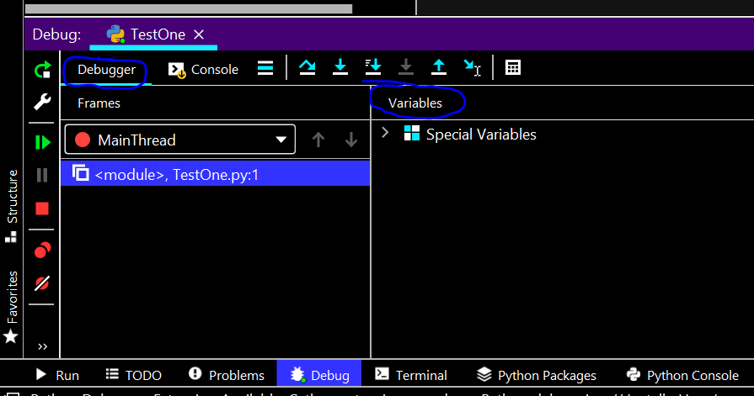

Console looks like this

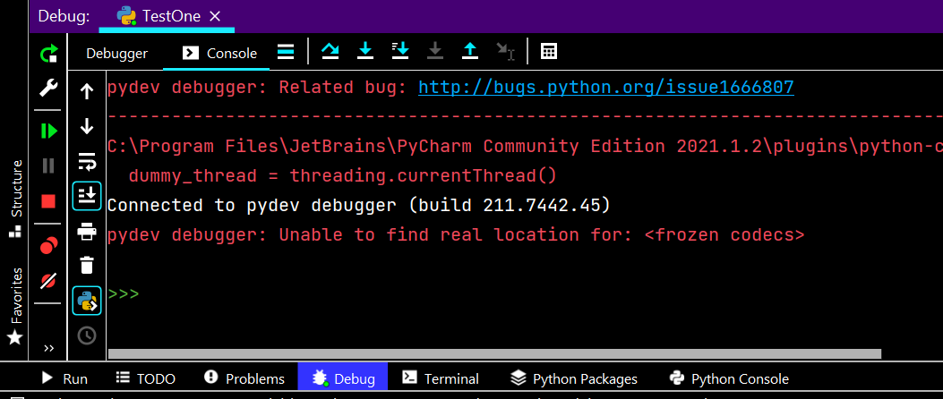

Now we have encountered the breakpoint in the 1st line itself so there is no value in the debugger. Click **alt+shift+f7** to step into once & below will be the code & debugger section view respectively

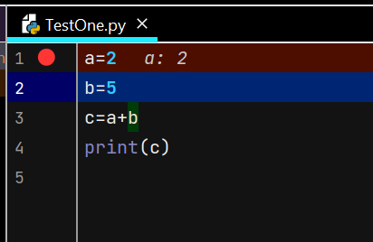

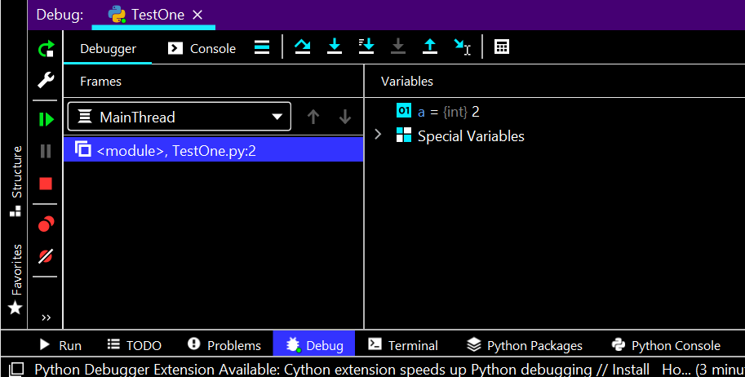

Execution in the code is in 2nd line as shown in the above image & output of 1st line is visible in the above variables section. Click **alt+shift+f7** to step into once. Now the code execution will be in 3rd line & debugger will have output of the 2nd line

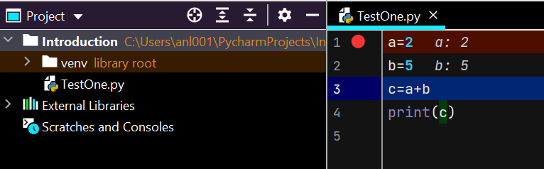

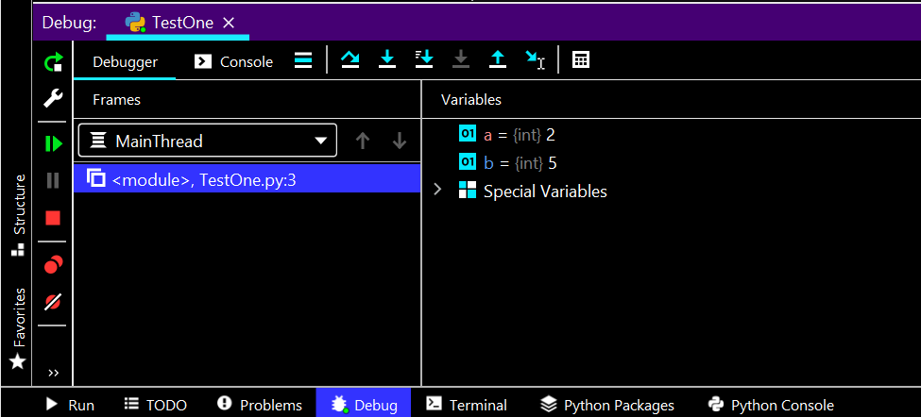

Step into one more time

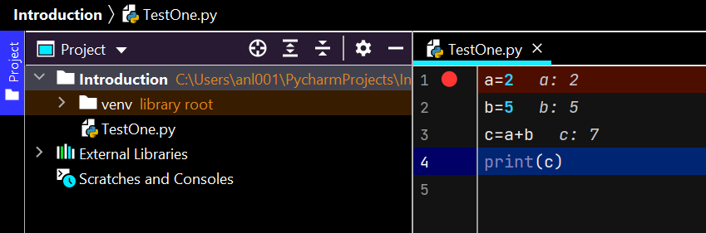

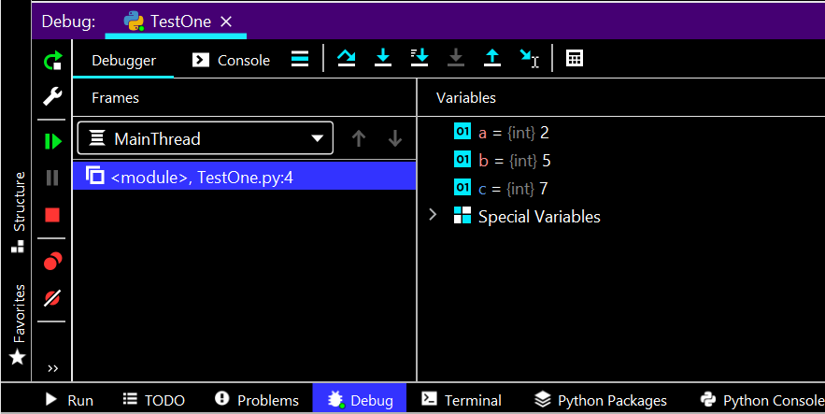

Step into one last time

Debugger will have no values as there is no next line to be executed

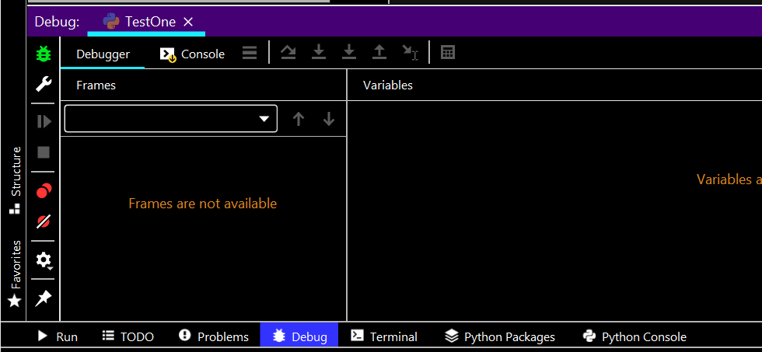

Console which had no output initially, now has output

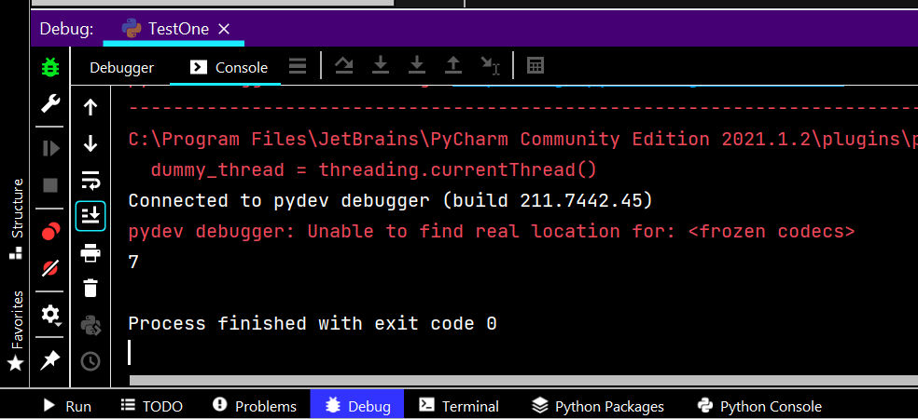

# User Input

Till now we placed with functions and by passing values but how to take values from the outside client?

Below we have 2 ways: Using input() and by running the code on command line

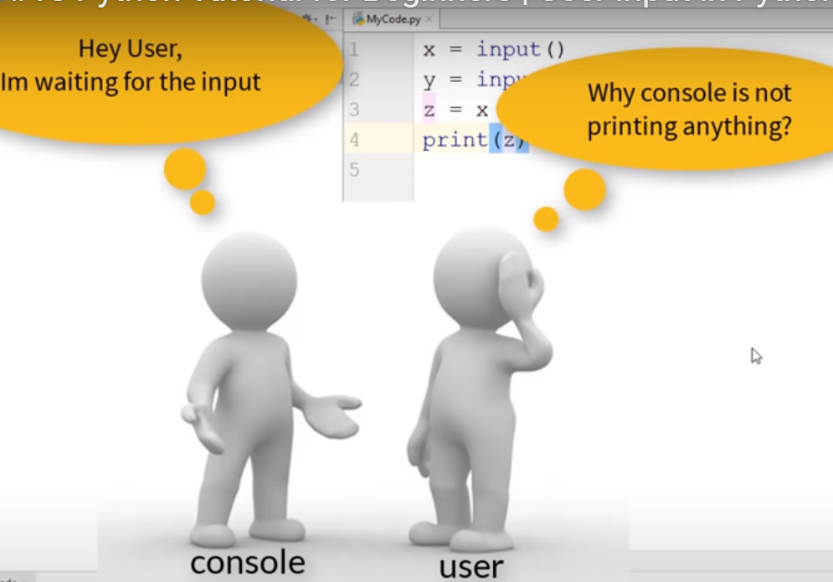

Output is empty below

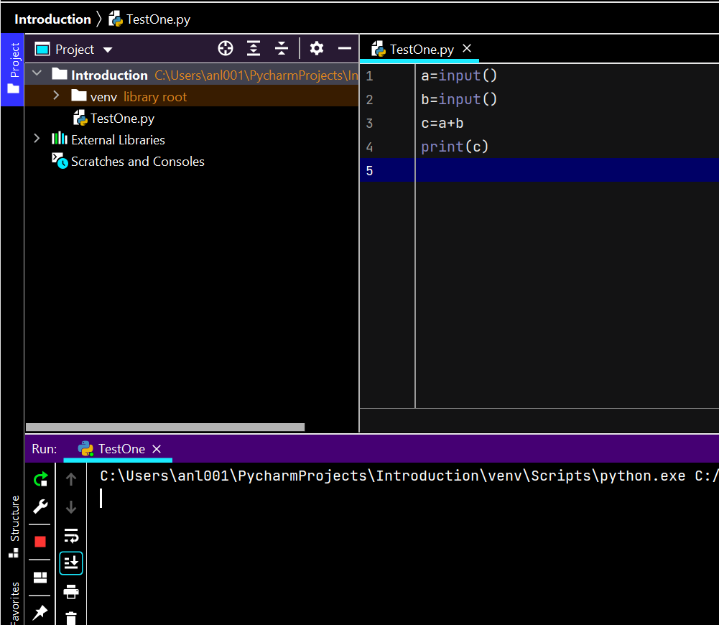

Console should notify user ‘hey I am waiting input from you’. For that we need to do something

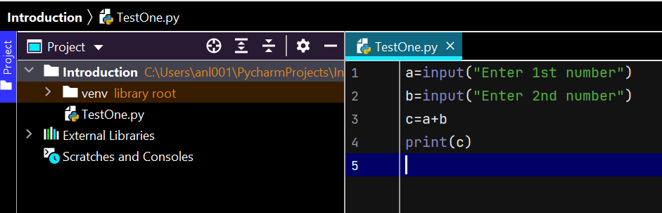

Output will ask questions to you

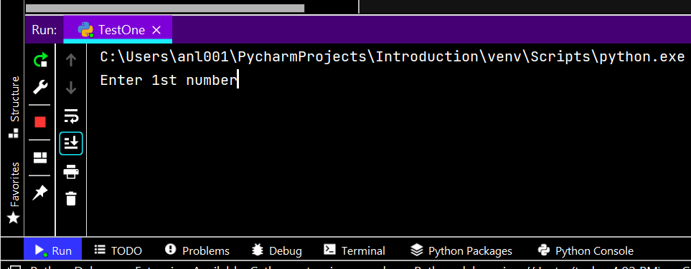

When we provide the inputs, output will be like below which is wrong

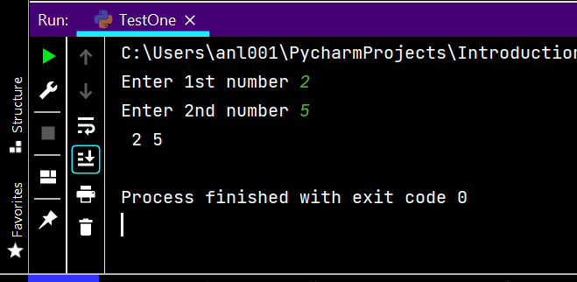

Try giving input without space

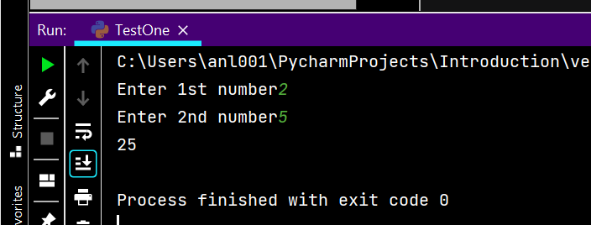

The above unexpected output is because it is thinking the inputs are strings so we need to give it a type

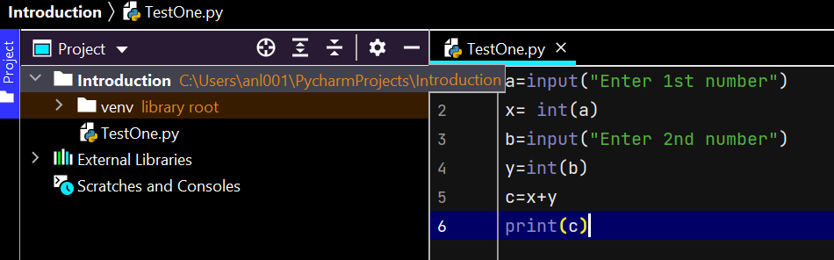

Output is below

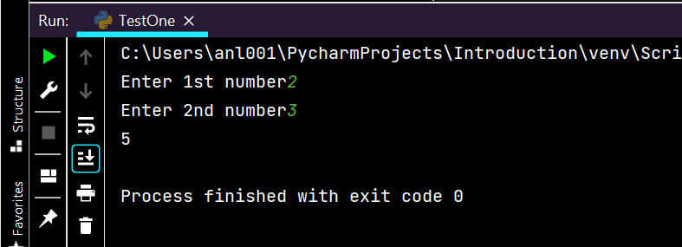

Now, how to reduce the lines in above code

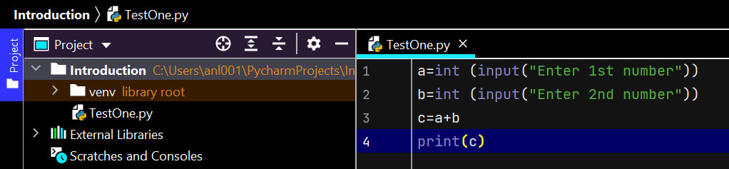

In python, there is no data type for character, so while writing a program this is what happens

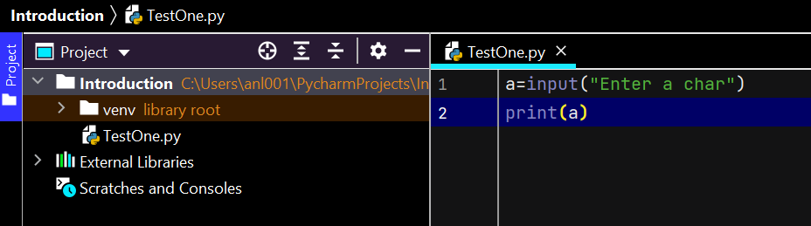

Even when mention “enter a char” if user enters a string, the whole string will be typed as output. To avoid this, there are 2 ways, one is we can fetch only one index. While printing output we can print only the 1st character

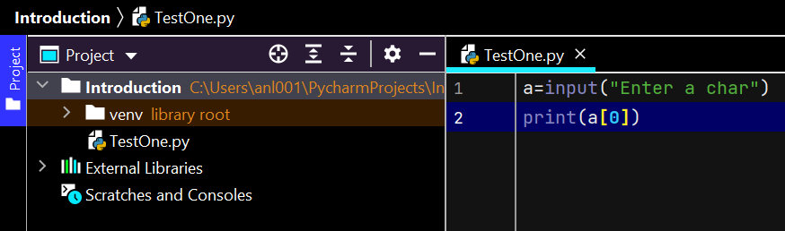

However, the variable will still have other characters in it, so to avoid getting a string as input, to get only char as input, we can receive only 1 character like below

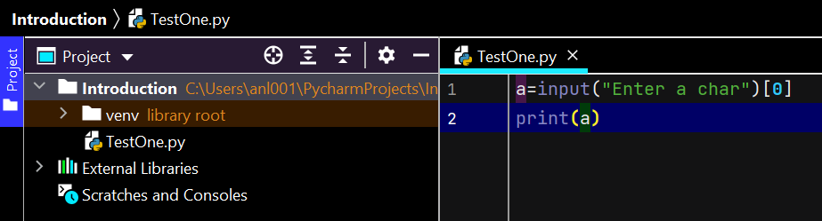

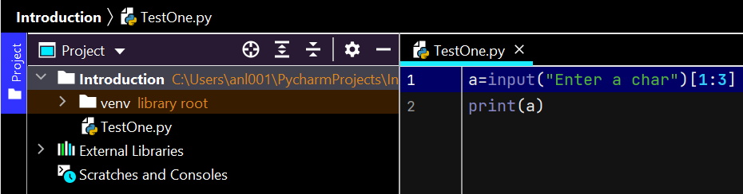

Output is below

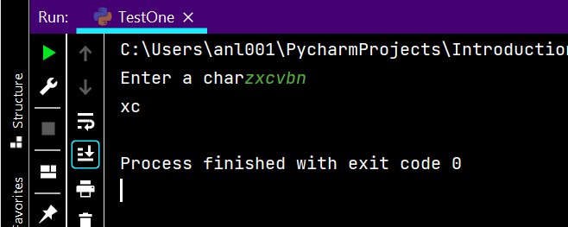

You can also pass expressions and get result but in that case you need to use a function called **eval**

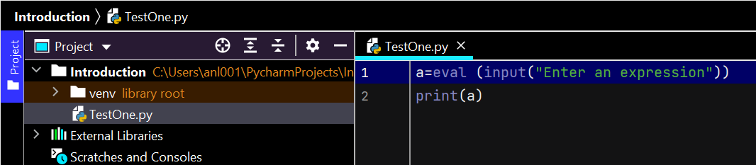

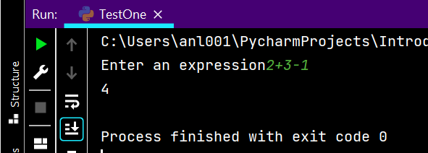

We can also call the code run from command line by passing the input.

1. We need to write the code and store in .py type of file
2. Call the directory in cmd prompt
3. Enter python and space and file name and space and input values

Below is the cmd where we executed the run

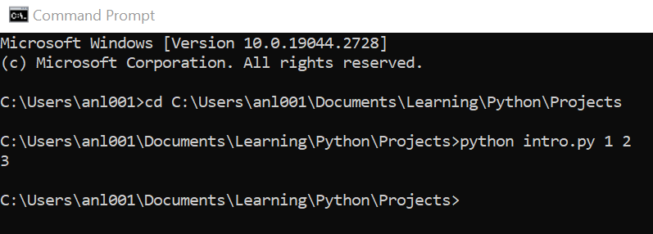

Below is the python file where code is written on IDE and stored in a path which was called in cmd cd

Here, above intro.py becomes the index 0, values become index 1 & 2 respectively for the below code

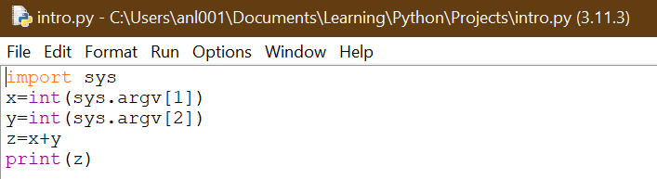

We know that we need to pass 2 arguments as input values & when you pass only 1, error will be thrown

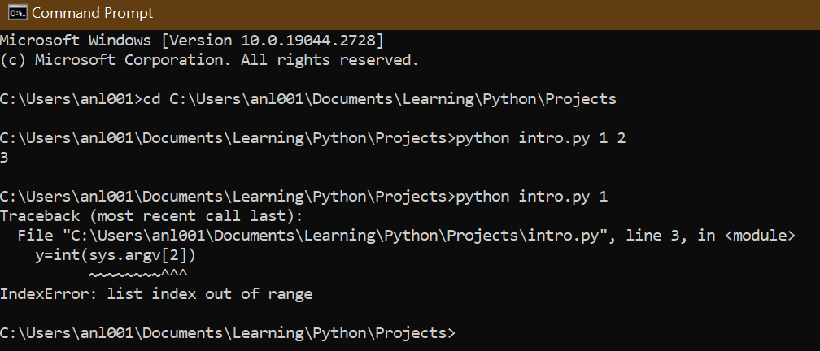

# If Elif Else Statements

Let’s talk about CPU which has 3 parts

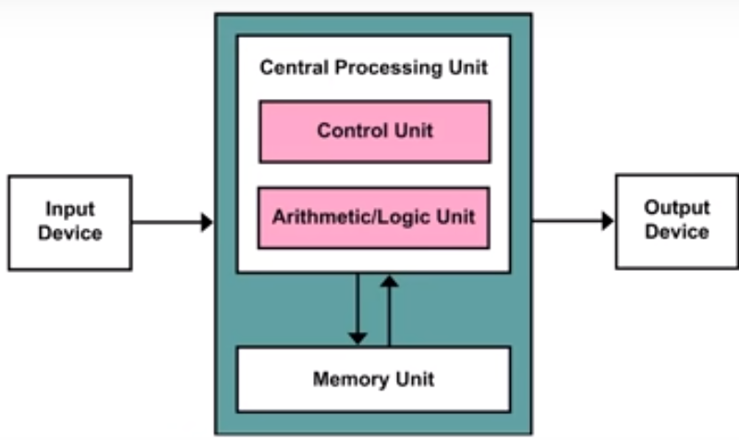

We have worked with Memory unit till now as we were using variables and storing them

Next one is ALU which has 2 parts- Arithmetic & Logic. When it comes to Arithmetic unit, it performs calculations. Logical unit is something which makes our computer think by writing the code by applying different conditions.

IF is basically a block, in python we call it as **Suite** where we can write multiple statements.

The below 1st print will execute only if the condition of the IF block is met & the outside print will execute in either of the situations because it is anyways outside the bock by default & is not restricted to any block

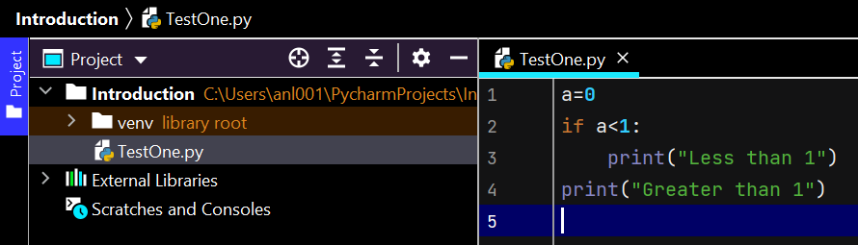

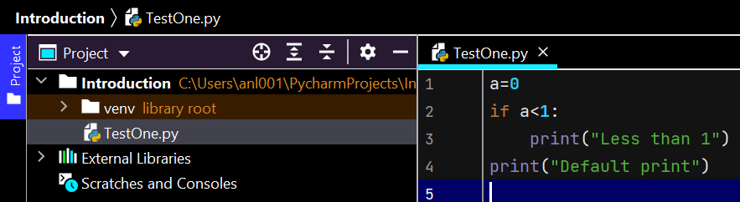

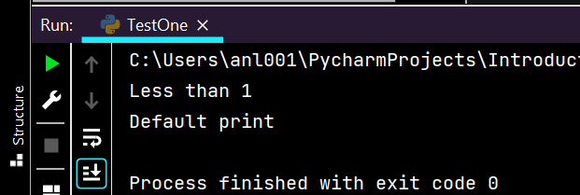

If we use else block then, the condition met block statements will execute along with default print if any

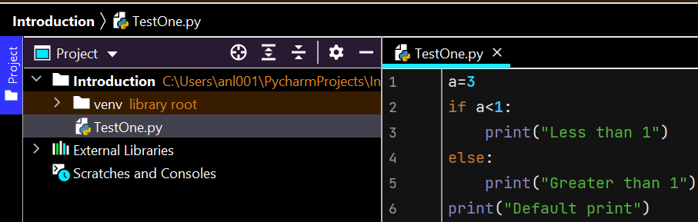

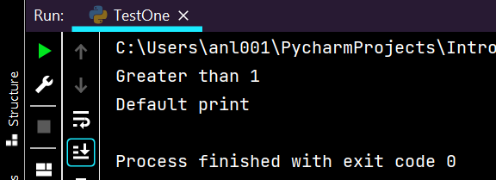

Indentation is nothing but the spaces which are used to show that statements belong to that block.

Usually, 4 spaces (1 tab) are given before the statement to show it belongs to the upper conditional block. Even if 3 spaces are given, it doesn’t belong to the block

In the below code, after checking for 1st IF statement, the execution will check for the next IF also which is not needed if we get the output in 1st IF itself

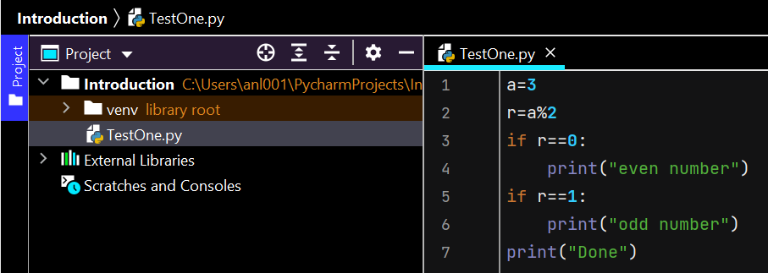

To replace the above requirement, we do the below code. If IF block is false then ELSE block will be executed or else ELSE block will not get executed.

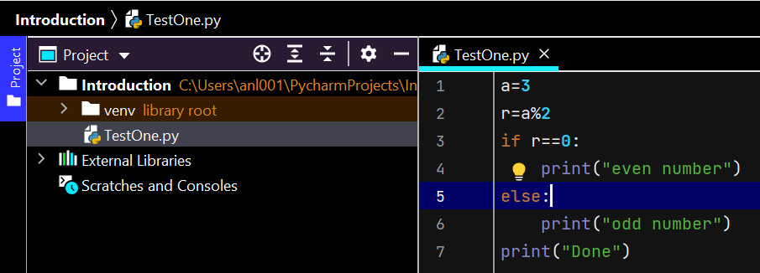

Nested If is If inside If which should have its own else. But the below gives syntax error as there is no ELSE for the nested IF

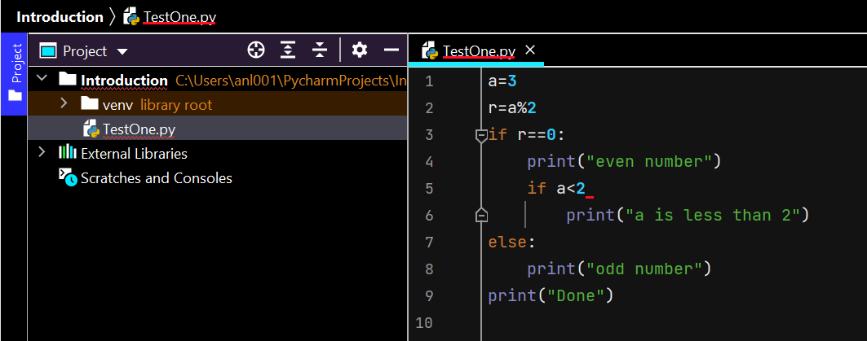

Here we have nested ELSE

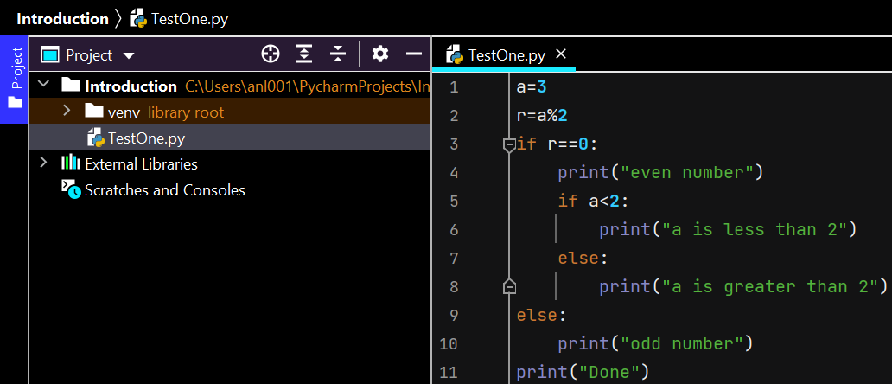

Below all conditional statements will be checked during execution, to avoid that we can use elif

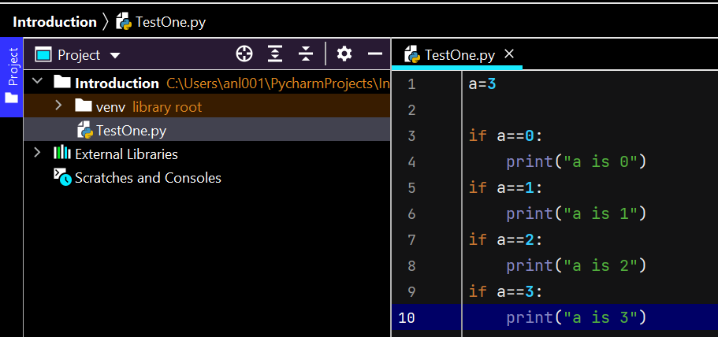

Above code is replaced with Elif where the statements will be skipped if condition is already met in the above IF or ELIF

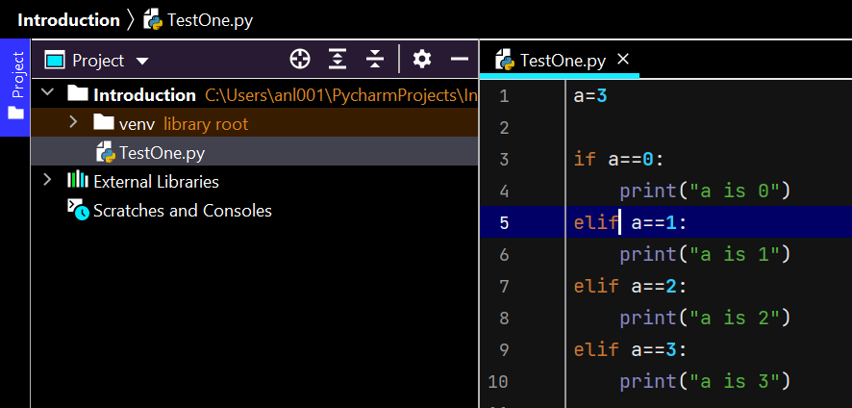

But what if a=5? We haven’t included any condition or statements for this and this is where we should use ELSE at the end

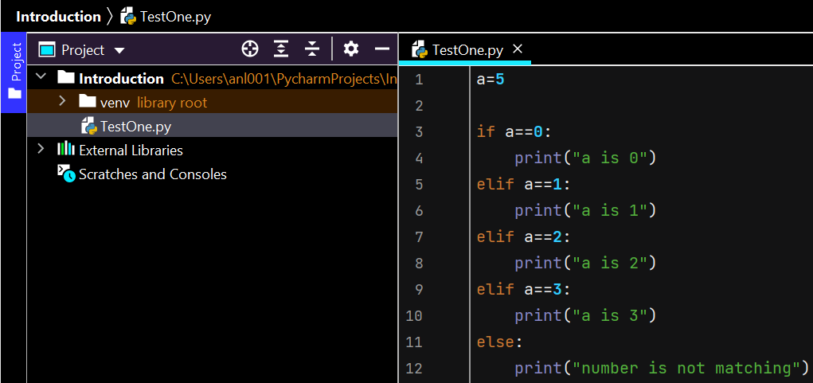

# While Loop

When you want to execute some statements until some condition is met, we use while loop.

We can also use while inside a while like how we used Nested If.

To type the below pattern:

**Hi Hello Hello Hello Hello**

**Hi Hello Hello Hello Hello**

**Hi Hello Hello Hello Hello**

**Hi Hello Hello Hello Hello**

**Hi Hello Hello Hello Hello**

This is something like each outer loop has 4 inner loops like each day has 24 hours

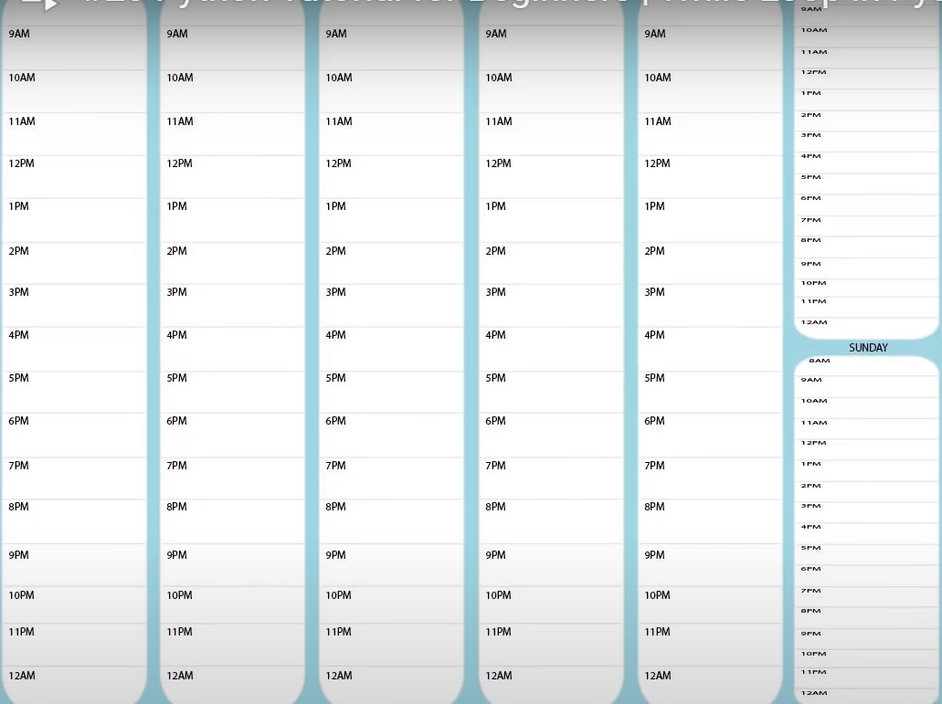

The below code prints output one below the other

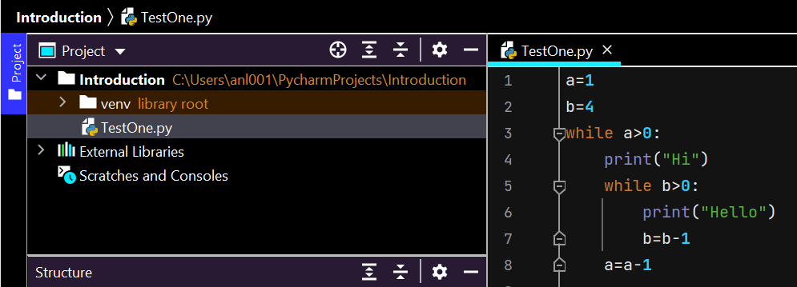

Output

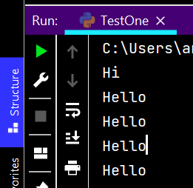 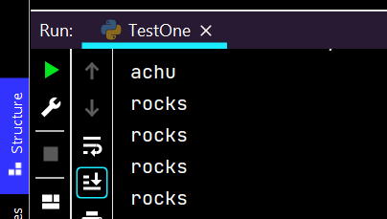

But I want output to get printed in a pattern like shown above for which I want the execution of 1 whole iteration to stay in 1 line until we go to 2nd iteration of 1st while loop

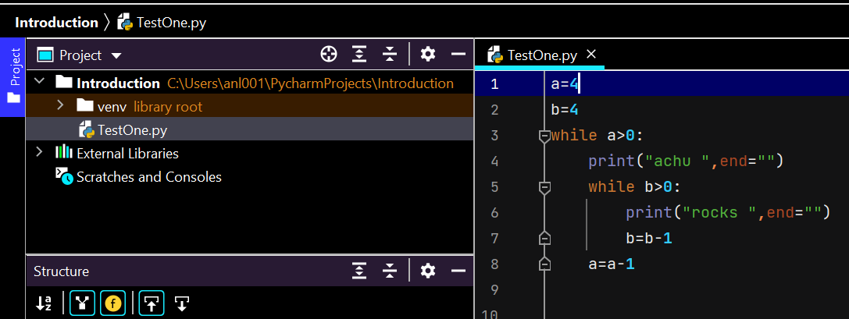

Output

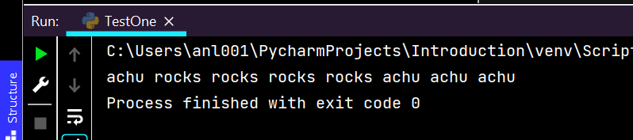

In the above output, I want the 2nd item achu to be printed in the below line and so I go to new line for 2nd iteration of 1st while loop

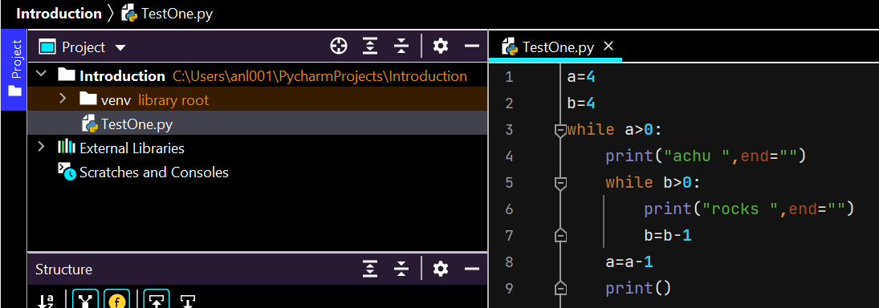

Output

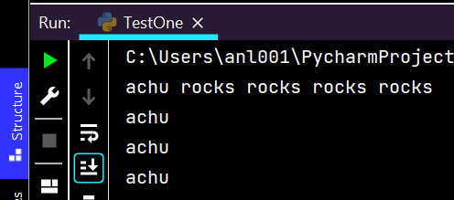

Rocks is not getting printed in the rest of the lines because rocks value got nullified. It should have its raw value for each 1st while loop. So assign the value inside 1st while loop

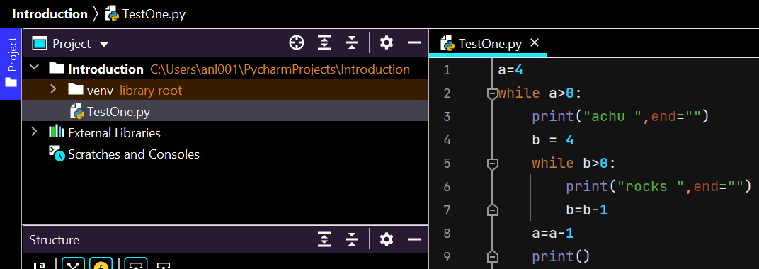

Final Output

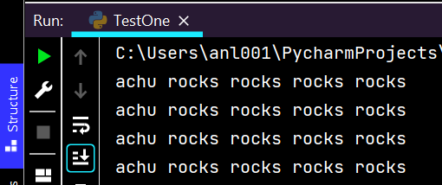

# FOR loop

While loop works on certain conditions whereas For loops works on certain sequence. There will be no increment/decrement or iterations like while loop. Example when we want to print values from a LIST.

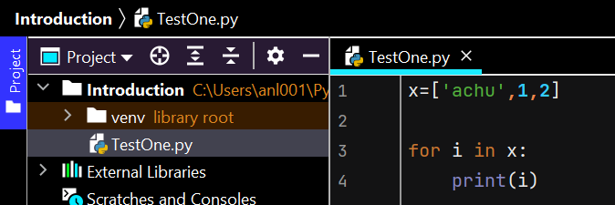

Output

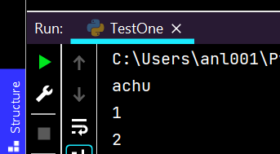

If we want to print every character in a string, for loop is the easiest like below

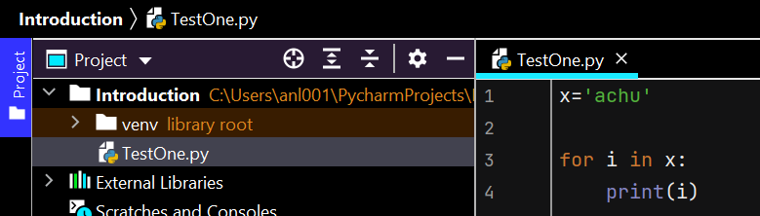

Output

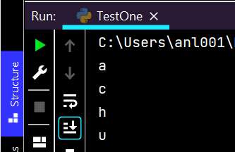

Instead of having a variable we can write like below

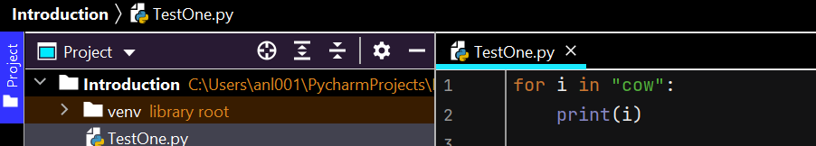

What if we want to type numbers from 1 to 10 as we did in while loop. Output will have 0 to 9

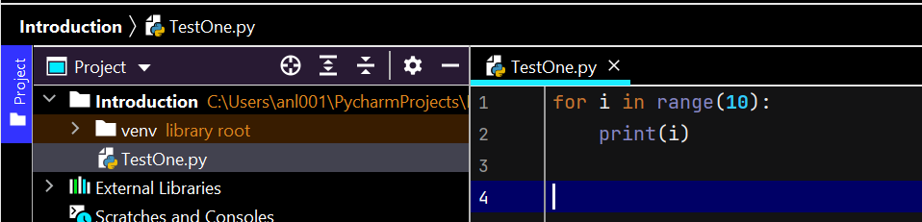

Type 10 to 13

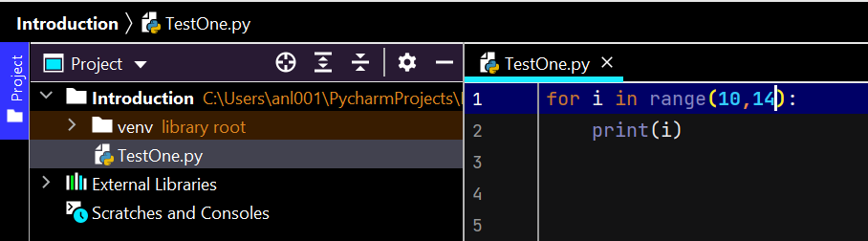

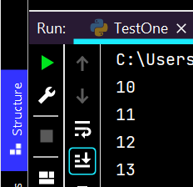

If you want to have some difference between the numbers

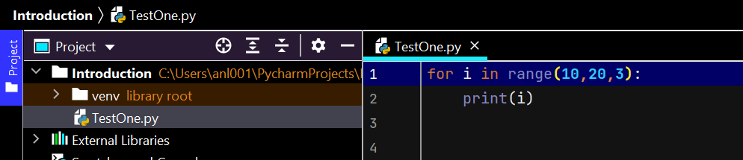

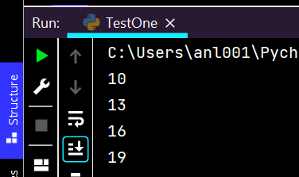

What if we have to print in reverse order, below gives null output

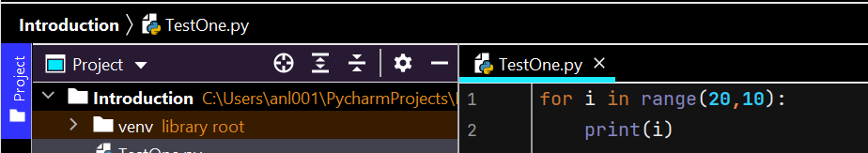

We have to specify the difference saying go backwards by showing the negative symbol

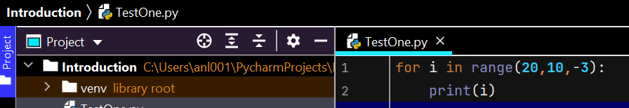

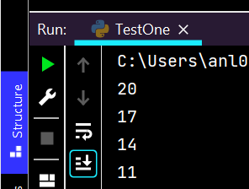

To print the values from 1 to 20 except those divisible by 2

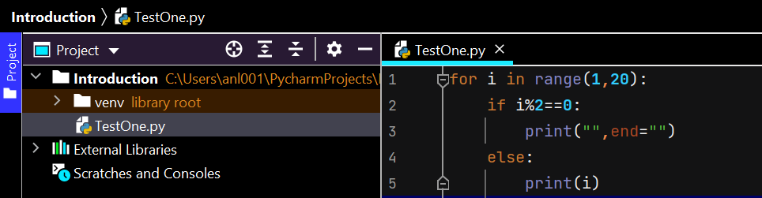

An alternative to the above code is:

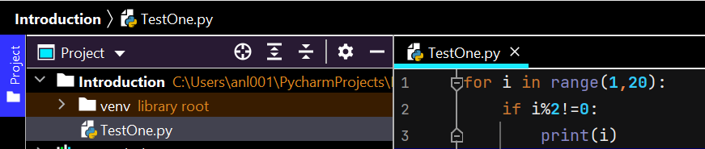

# Break Continue Pass

When we want to execute a set of statements for a specific number of time & then stop, we can use Break.

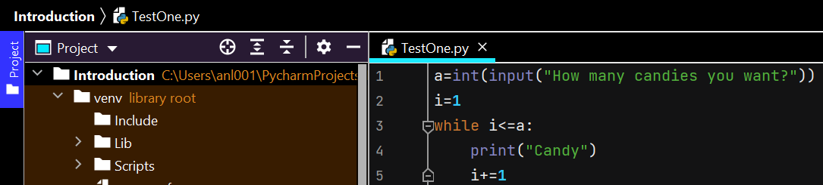

The twist is what if user asks 100 candies which isn’t available

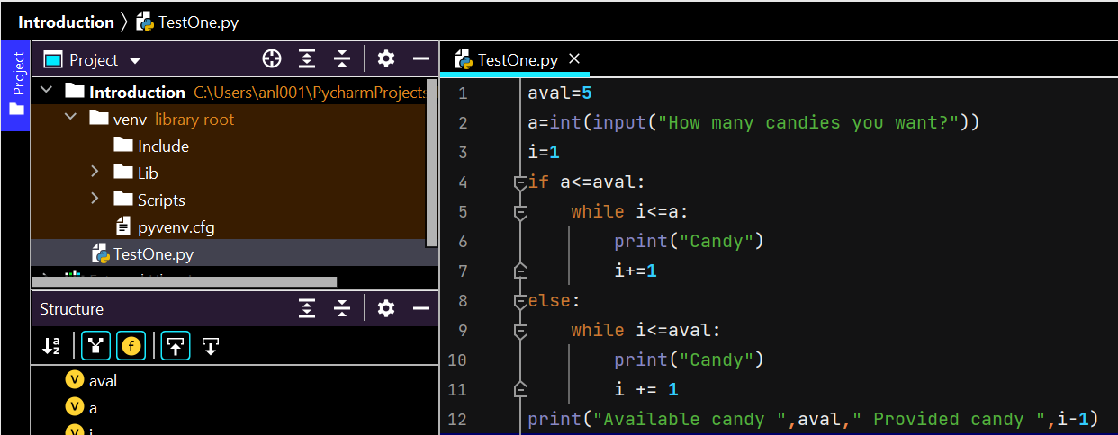

Instead of the above way, we can modify the code like this

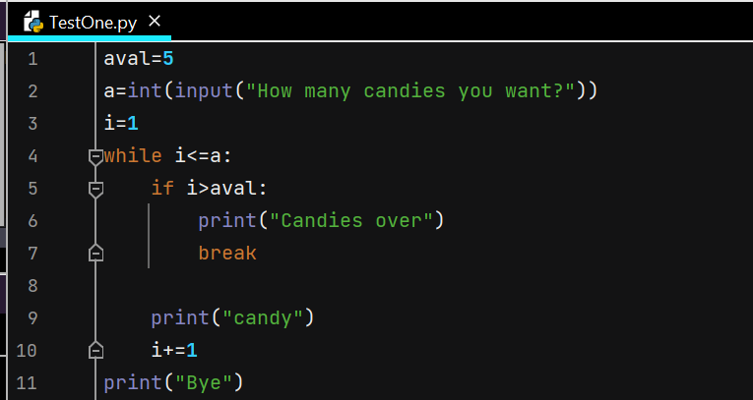

When we want to print values from 1 to 20 which is not divisible by 3 & 5. We make use of **CONTINUE** to not break the loop & continue execution

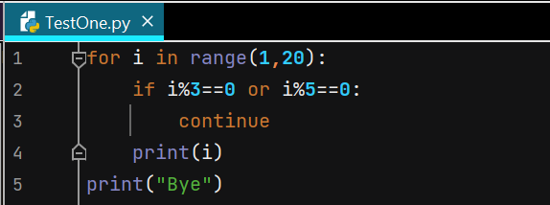

Here above, when IF loop is true, then the continue will happen and execution moves to FOR loop & pick the next value. Means, instead of breaking the whole loop, it will skip the whole loop for that iteration.

How to use PASS?

When we want to print numbers from 1-10 which are only even & ignore the odd ones, and we focus on ignoring the odd ones more than printing the even ones.

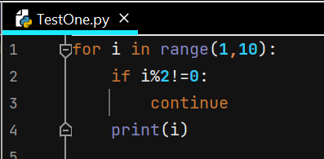

The above code in continue gives output 2,4,6,8

But the same code in pass is giving output 1-9. Because continue is skipping the current iteration & going to next number. Pass is just passing the IF loop & printing the “i” which is outside IF but inside FOR loop

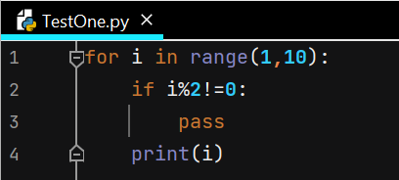

To get even output with pass, we need to slightly modify the code like below

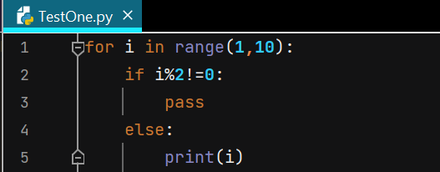

|  |  |  |
| --- | --- | --- |
| **Break** | **Continue** | **Pass** |
| Breaks the whole loop & executes the next set of activities | Breaks current iteration of child loop & goes to the next iteration of the master loop. Doesn’t go to the next set of statements after executing CONTINUE | Breaks current iteration of child loop & goes to the (next loops if any and then the) next iteration of the master loop |

# Printing Patterns

Print the below pattern using all the loops



Using while loop

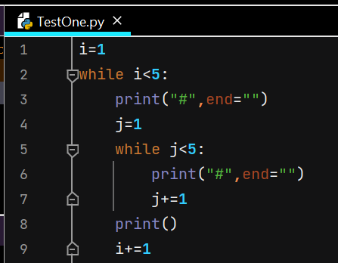

Using FOR loop

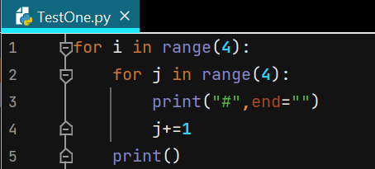

In 2 loops, “i” represents number of rows and “j” represents number of columns. Number of columns depend on the row number.

Print the below pattern

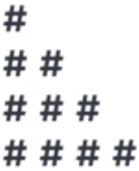 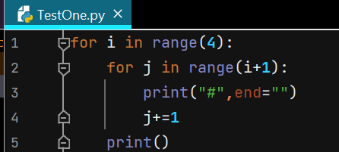

Print the below pattern

 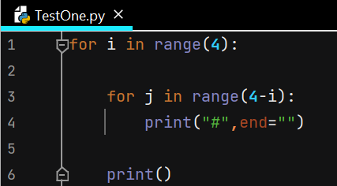

Here above, when i=0, j=4 so 1 row will have 4 columns. When i=1, j=3 so 2nd row will have 3 columns

# FOR Else

If we are coming from other languages like C or java, we know that else comes along with If loop & For comes alone. Here we have For and Else together.

We want to print only multiples of 5

The below prints all numbers divisible by 5

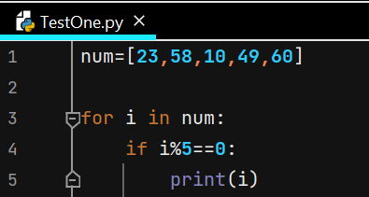

The below prints only 1st number divisible by 5

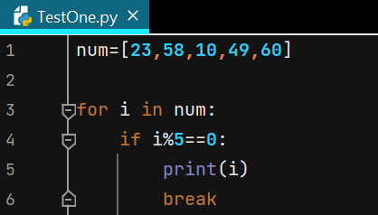

But what if you do not have any number divisible by 5 in the input? You will get blank output. To avoid this, we use else loop

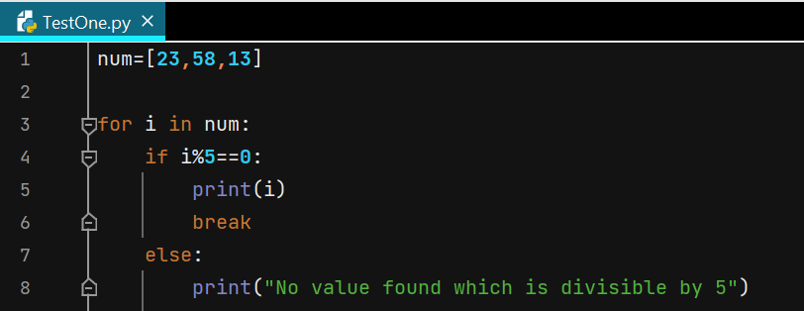

But the above prints the NA value many times like below

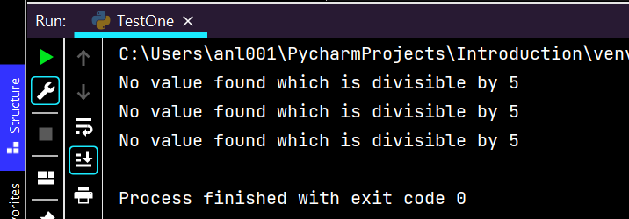

To print it only once we can use below. Here **pass/continue** will give same value

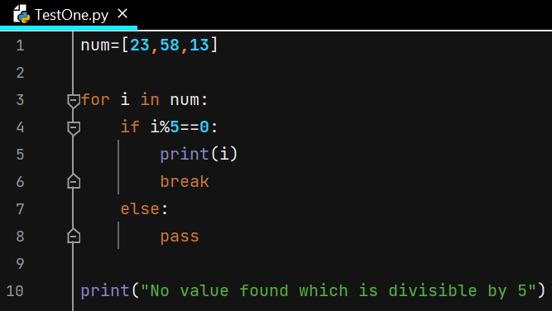

We can also print this else outside If loop & remove pass

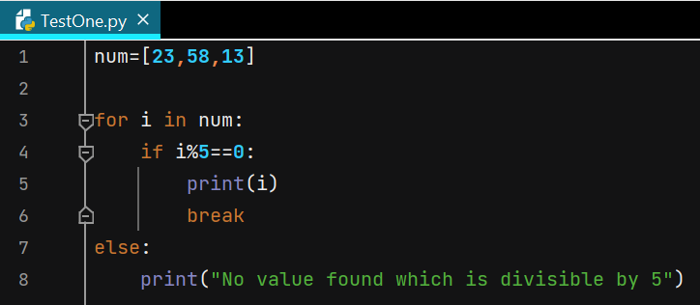

# Functions

When we are dealing with complex projects, we divide it into smaller parts. In these small tasks we will be writing multiple statements. We can keep all these statements together to re-use it multiple times by calling.

Apart from many inbuilt functions, we can create our own functions. There are 2 steps:

1. Define a function
2. Call a function

Define a function – **def greet():** By using these brackets we define that greet is not a variable but a function. All the statements which are inside that function colon : are together called as suite.

A function will provide output only when you call it and not just by defining it like below

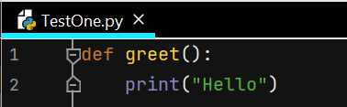 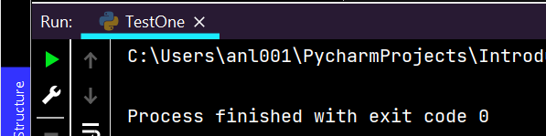

Below is the way to call function that is already defined

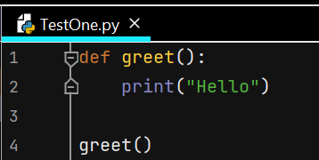 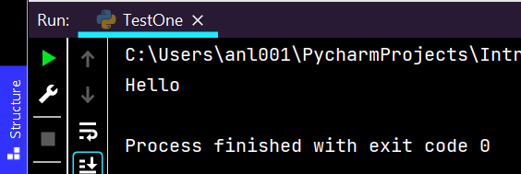

One basic example of defining & calling function along with taking input from user in runtime

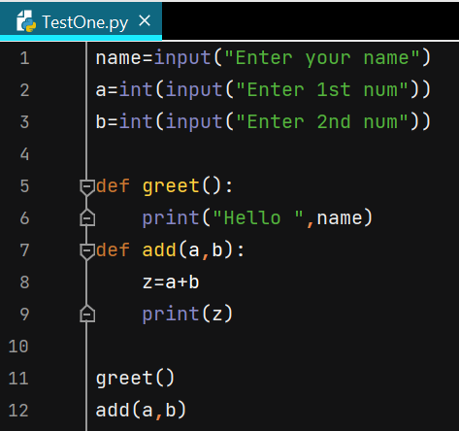 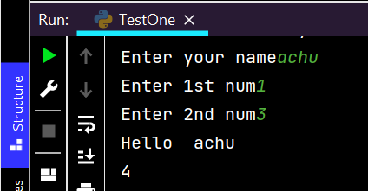

There’s another way of returning result from function. Below doesn’t print result because there is no return function in the function add(), but z will get printed as print is there inside it

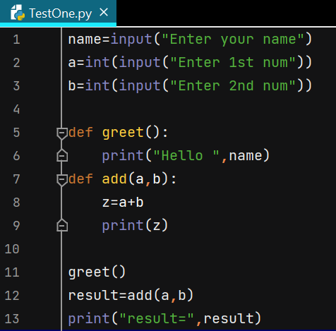 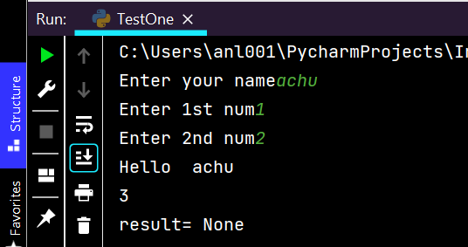

Below returns the value and so result is printed

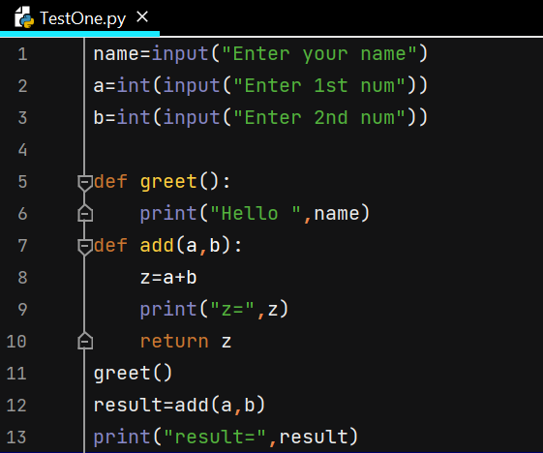 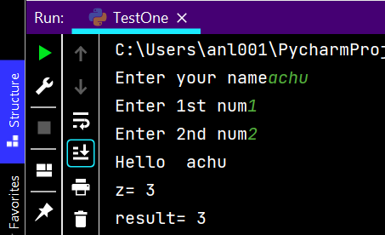

Below is the clear example

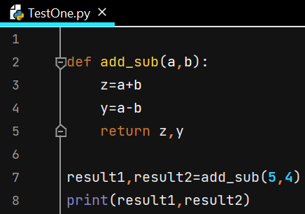 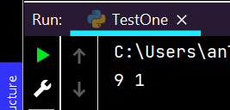

# Function Arguments

When we want to use a concept of modularity, we use functions. Let’s discuss on how to pass parameters to functions.

There are 2 concepts: **Pass by value & Pass by reference**

1. Pass by value: We pass a value & not the address, inside a function

An example is below

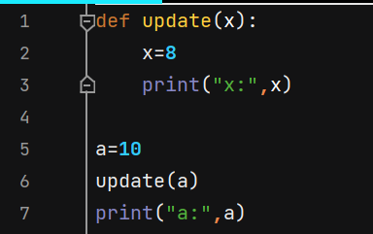 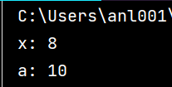

1. Pass by reference: We pass the address itself. An example is below

Irrespective of the values, before values are stored/passed, if we are trying to print the address, it is same as 1at a is initialized and then the function argument x is replaced by a and so the address is same, but value of x will not be a as it will get changed. So, values are different, but address is same.

Address is changed once the value of x is changed

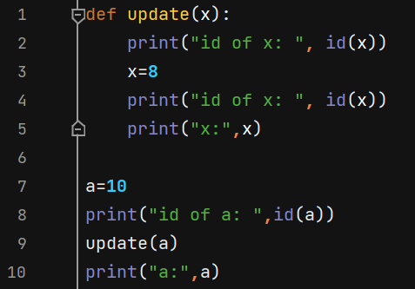 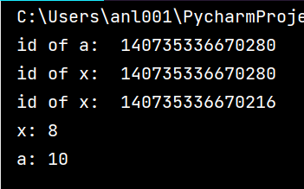

What if we pass List inside a function?

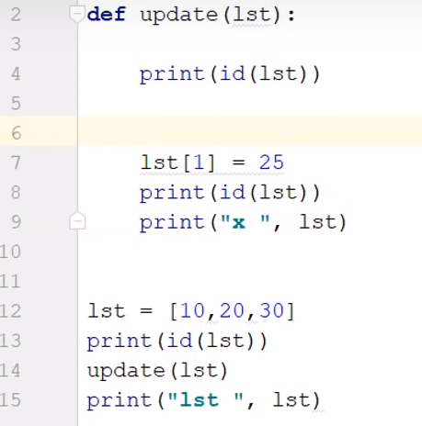 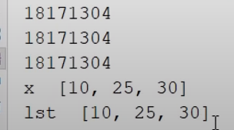

It has same address throught and value is also mutuable.

# Types of Arguments

In the below case, we have to pass 2 parameters/arguments because function will accept 2 arguments to perform operation & so we need to pass 2 arguments

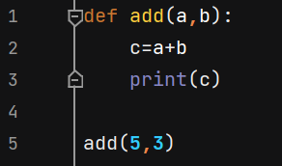

If you pass only 1 argument, then it is error

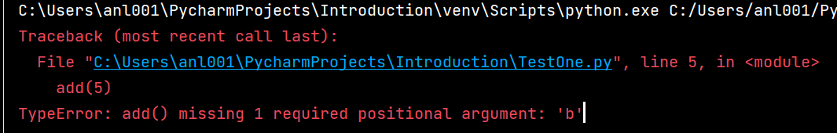

Here we see 2 arguments: **Formal & Actual arguments**

Formal argument is add(a,b) & Actual argument is add(5,3) where we pass actual value

Actual argument has 4 types: **Position, keyword, default, variable length**

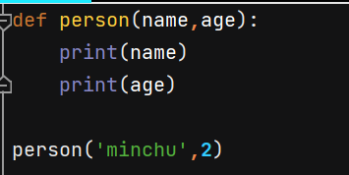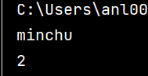

It is exactly printing the person’s name when we asked to print name. This is with the help of **position** type of argument we stated above. This will work only when the input sequence we pass is matching with the formal arguments.

Even when the sequence is interchanged, no error will be thrown but when you try to perform any operation on the age, error happens.

Below is the **keyword** type of argument

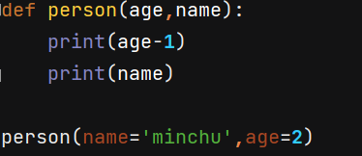 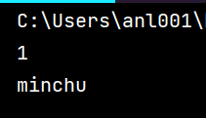

Default is something that saves you from error when that one argument (already having value) is not passed

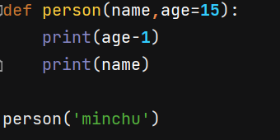 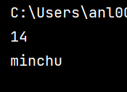

And when you pass value, it takes the passed value, if not it takes the default value it has

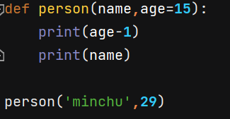 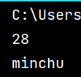

Below is the **variable length argument.** In the code, *b indicates it can take multiple values as tuple

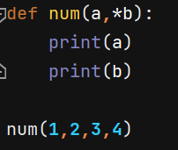 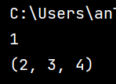

Below is another code

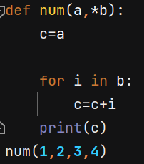 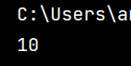

# Keyword Variable Length Argument

When we are passing **multiple data WITH keyword** then we must use this argument by using **double star**

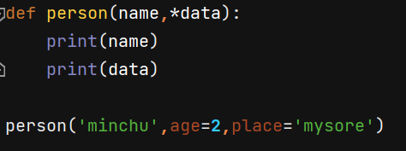

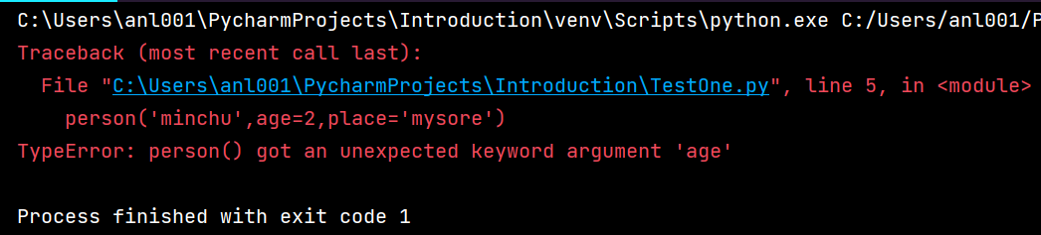

Above code can be corrected using double star **

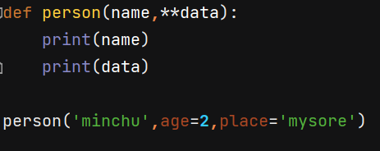 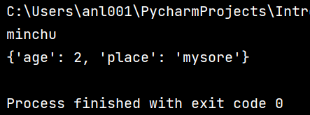

We can also use a FOR loop to print key and value pairs like below

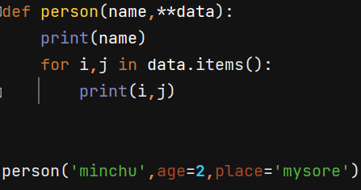 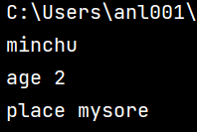

# Global keyword

Variables can be created inside as well as outside functions. Scope is something that helps us know where in the program, the variable is valid

**Local variable** – valid only inside the function where it is created

**Global variable** – valid throughout the program & its value changes when it goes inside a function which has its own value for this variable

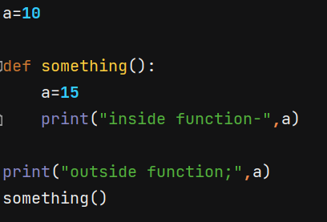 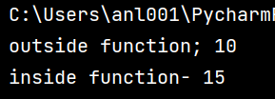

This will print a which is global variable and then function is called where a is 15. Let’s declare a variable inside function and try to print outside like below

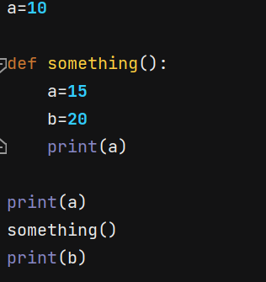 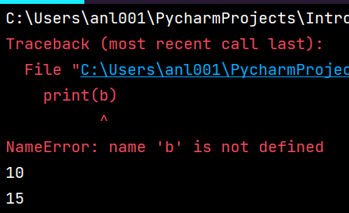

Error is thrown above as b is not a global variable and I tried to call it globally

**NOTE: Preferable will always be given to local variable instead of global variable**

But when you do not have any local variable but is called inside function & code has only global variable

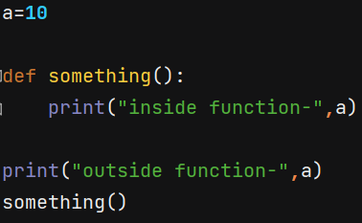 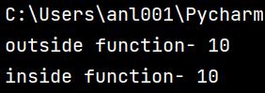

We can also make local variable as global even after it is defined inside a scope/function like below

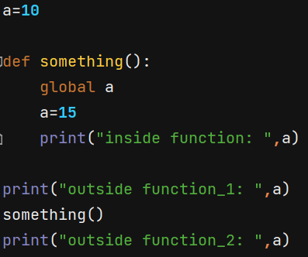 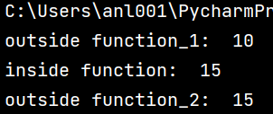

Even though I have made “a” as global variable, once we assign a new value, it changes the value but again treats it as global like below. Even though a=9 is inside function, its value is printed outside scope also as it because global the moment it was made global

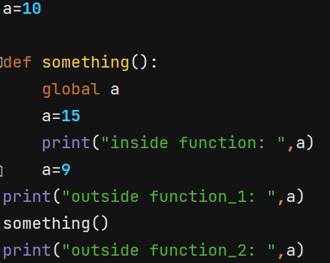 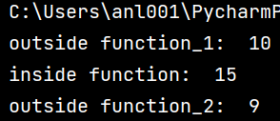

How to have global & local variable together inside a function?

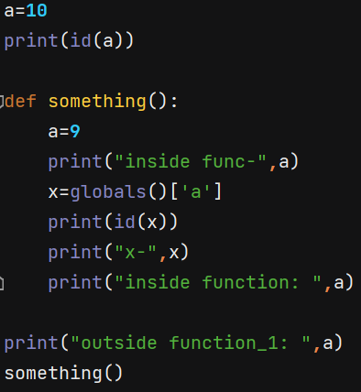

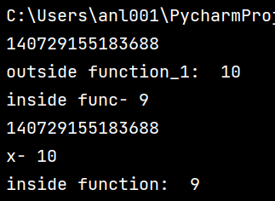

Above the addresses are same and hence global will be assigned to variable ‘a’

Without changing the global variable, if you want to change its value you can do below

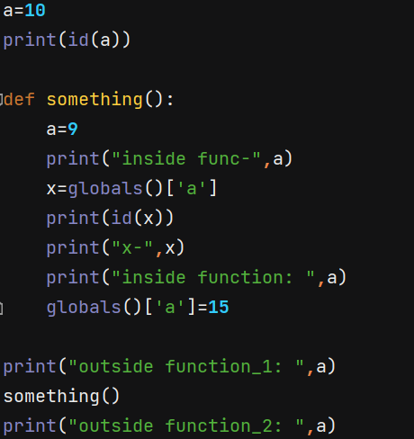

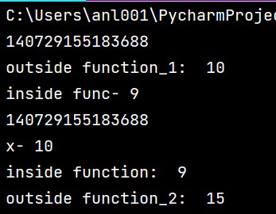

# Decorators

Decorators help us add extra features in the existing function

Decorator is a function that takes another function and extends the behavior of the latter function without explicitly modifying it

You'll use a decorator when you need to change the behavior of a function without modifying the function itself. A few good examples are when you want to add logging, test performance, perform caching, verify permissions, and so on

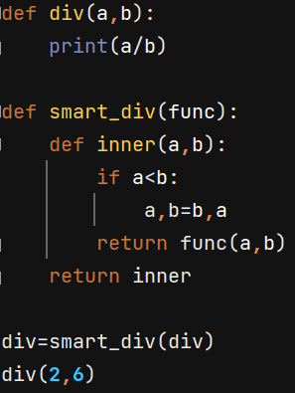 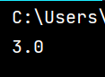

1st we are defining the function which fulfills our requirement

2nd we are defining a smart function which accepts function as its argument & then creates another inner function which swaps the numbers based on condition and returns values in the form of function with 2 arguments and then that is returned by inner function to the main smart div

3rd we are linking our required function with smart div

4th we are calling our function

# Modules

Instead of writing 1 big software in 1 file, we can break it down into small parts.

Uses are: Suppose we have 4 modules

1. When you want to make changes in module 1, it will not affect the functionality of other modules
2. We can also reuse these modules wherever we need it even in other projects
3. We can create all 4 operations (add,sub,mul,div) in 1 module or have separate modules for separate operations. For this we need to create a separate python file

Let’s create a python file Calc for performing calculations

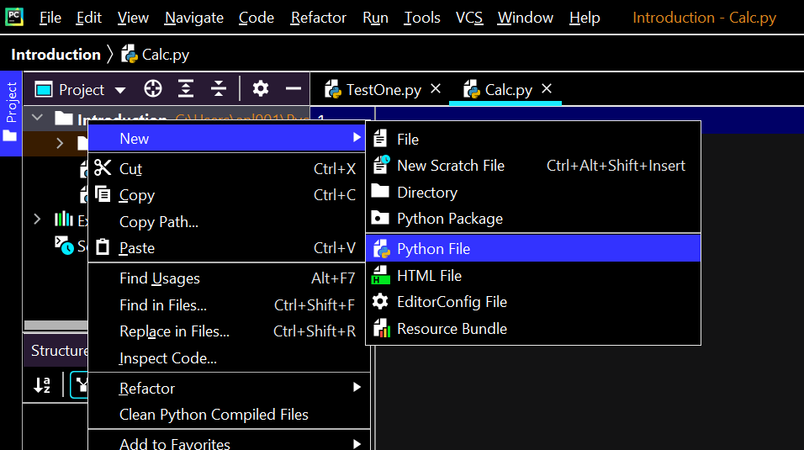

We have defined all the operations in Calc file Calc.py and need to call this module in our project file TestOne.py

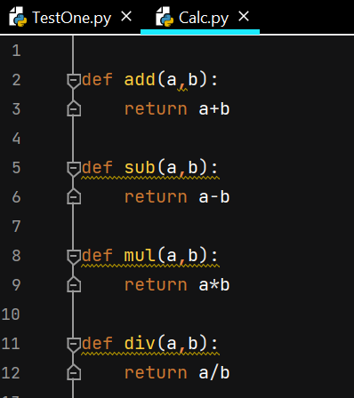

If we just say add(a,b) in our project file, we cannot get required output because this is defined in other project file and has to be called or imported. But we use import key to import inbuilt modules & how about the modules we have built? Calc is my own module now

Doesn’t make sense to have separate modules for separate operation. Instead, we can import * from the module and call any functions defined in the Calc.

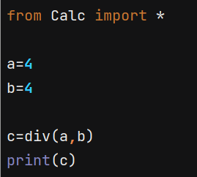 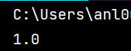

# Special variable__name__

What happens when you print this?

Main is a static point of execution. 1st module name is always name because that is the point of execution. That’s where your code starts.

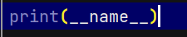 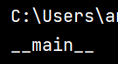

If you are just printing the __name__ it says main like below

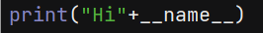 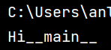

Now try importing this code in another project & then print & see what you get.

Calc file is having below

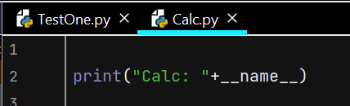

Importing above file in TestOne like below. Here the imported statement is giving its module name instead of main

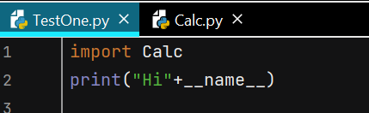 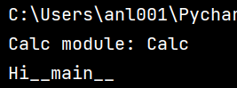

So this variable “__name__” value changes depending upon the place it is used.

Another example: Calc is my main file and we are importing TestOne in it.

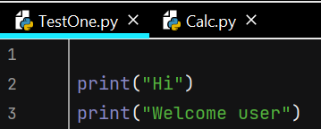 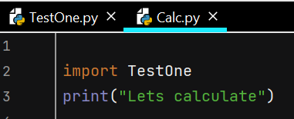

Output of above is like below

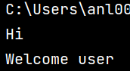 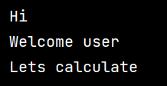

Now, what if you don not want to print this Hi Welcome user when you are not running the base code. Assume we are calling this Hi Welcome user module again and again and we don’t want this greeting. You need to print this greeting only when it is the main/first code.

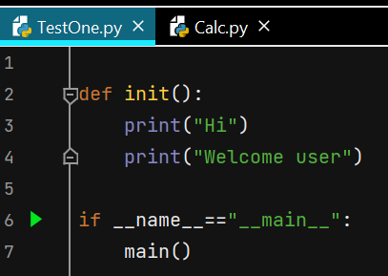 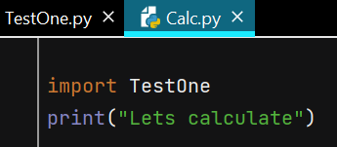

Output of above Calc file is below: It is not greeting the user because TestOne is not the main file (so __name__ will not be __main__ but it will be the module name TestOne) & TestOne is the called file

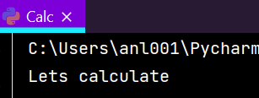

# Object Oriented Programming

Even human is an object that use laptop object. Every object has attribute (age, name, company) & behavior (talking, dancing, actions define behavior)

Object will have something to store data like variables. If you want to define behavior, we need to use METHODS.

Functions in Oops are called as Methods. In Oops there are many concepts like Object, Class, Encapsulation, Abstraction & Polymorphism.

Whichever program you work on we use Objects & class together. Example there are 5000 phones. We don’t say it is Indian manufactured or China manufactured, doesn’t matter from where it was manufactured and we call it from its name from where it got designed like apple, Samsung, oppo. It is Designed ONLY ONCE and manufactured multiple times. This design in Oops is called as CLASS.

Assume there is a factory to where you need to produce a design & then manufacture thousands of projects. CLASS is a design & Objects are real stuffs/Instances. Using CLASS, we can manufacture OBJECTs

CLASS – Design or Blueprint

OBJECT – Instance or real stuff

# Class and Object

Before creating an object, we need to create class right because that is the design. Like creating blueprint before building a tower.

 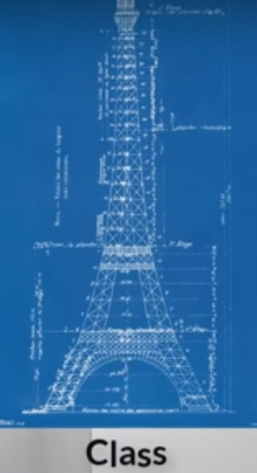

If I want to work with computer, I want an object of the computer. Lets say com1 is my computer 1. Till now we have worked with int, float and all these are inbuilt types. Com1 is our own type and so we need to define our own class

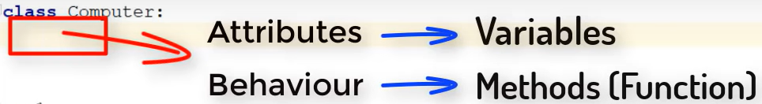

Once we define a class, we can define its attributes & behaviour inside it. Let’s define a CLASS & create a method (function) in it. The word “self” automatically popped up inside the argument section (lets check later)

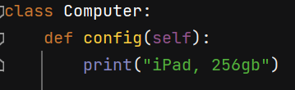

In python we no need to define the types. If you just say a=1 it is understood as integer and a=’1’ is string. Similary if you just type com1, none can understand as this is not inbuit type so we need to mention that this com1 is an object of computer

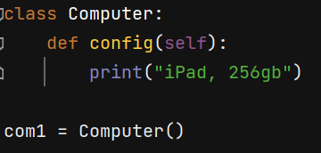

Now this will give com1 an object of Computer. In Java, C# we have a concept called Constructor right, this is that. If you want to know the type of com1 now, check like below

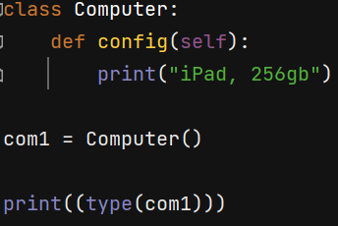 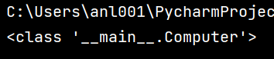

If you try for string you get below

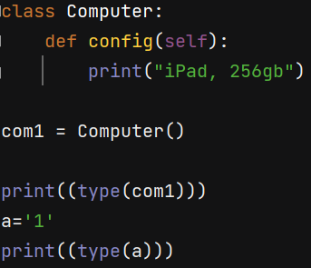 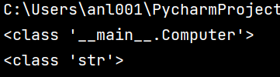

It says <class ‘str’> so we are using this concept from a long time but this is where we are defining it now. Str is inbuilt class and computer is our built class

Lets try to get the config data

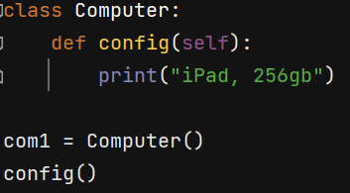 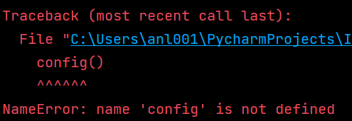

It is giving error because till now we were defining a function & simply calling but here we have defined inside a class. Inorder to access that we need to give class name as well

NOTE: If you want to call a method, you should mention its class also.

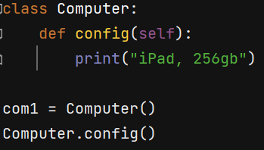 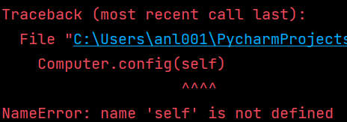

A class can have multiple objects and here we are using only 1 that is com1. And this config function will change its behaviour based on the objects right. Because different object have different behavior. So if im calling config, for which object im calling it for? When you say walk, whom are you supposed to make walk.

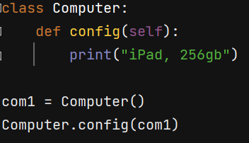 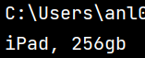

Here above you are calling config of com1 and com1 is treated as self here.

Lets create 1 more object com2. Now we have 2 objects but 1 class

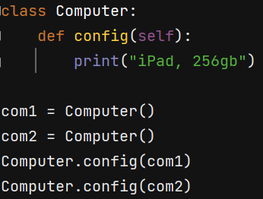 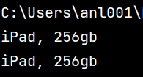

At this moment we are getting same output because we have same configuration for all objects defined in the class, we don’t have different config for diff objects yet.

We can use object itself to call the function like com1.config(). Here behind the scene config () will take com1 as a parameter inside it even though it is not passed inside ().

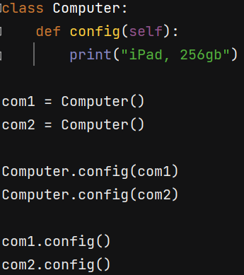 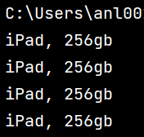

So, Self is the object that you are passing inside the method. A small example will illustrate this like above and also below one.

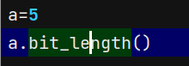

If you Control+Click on the bit.length inbuilt method, we get a documentation also.

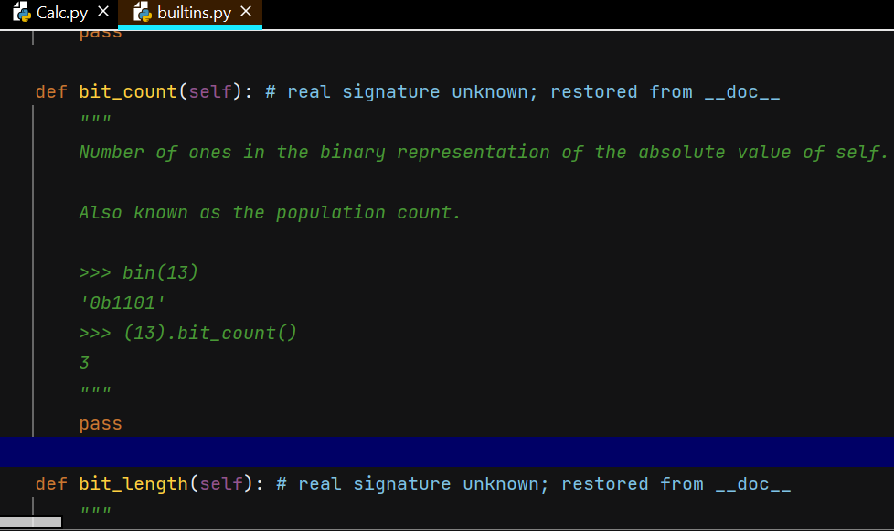

# __init__

As discussed previously, we can remove the 1st 2 lines and keep the last 2 lines for calling Config.

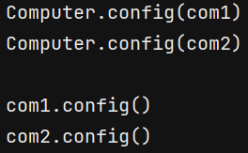

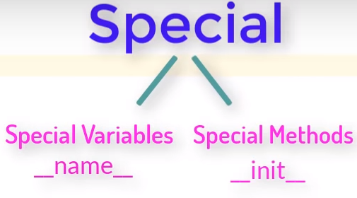

Normally we use init to initialize variables right.

If you want to work with config then you need to call it as a function or method. It is compulsory to call config to execute it right but the idea behind __init__ is it will be getting called automatically.

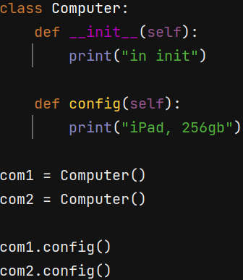 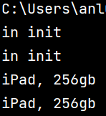

Output has 2 times printed init statements because it gets called “object” number of times. We have 2 objects com1=Computer() and com2=Computer() and so it is called 2 times.

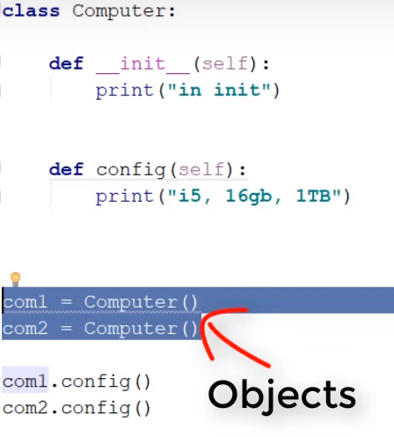

When you say Computer(), it will instantiate, it will call init for you.

Now I want to pass some arguments & we can do that in the constructor itself within Computer().

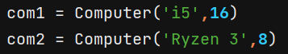

To accept these values, we need to create arguments in the methods also right.

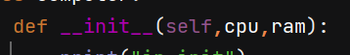

We are passing only 2 variables but having 3 arguments while accepting. Self is nothing but the object itself so com1 will be the object passed in self and rest 2 variables are arguments cpu and ram.

The moment you say Computer() it means com1 is getting passed through this bracket by default.

Cpu and ram are just arguments 7 if you want this to be a part of the object, we need to assign it to object

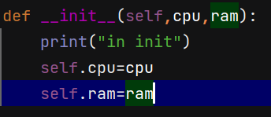

So whatever value we pass like i5 goes to the cpu and gets assigned to self that means object that is com1. Now in the config we can have this printed like below

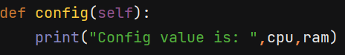

But we get an error like below

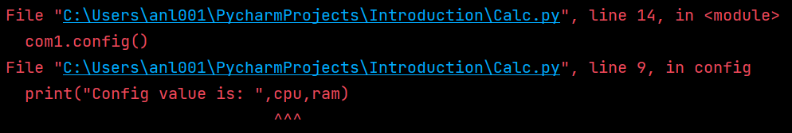

It means cpu and ram are not local variables, they belong to an object and so we need to refer to an object which means self. So the above should be modified like below

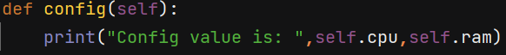

1 object will have its own method & variable & they are working together. We are binding our data with every method.

FINAL OUTPUT & CODE

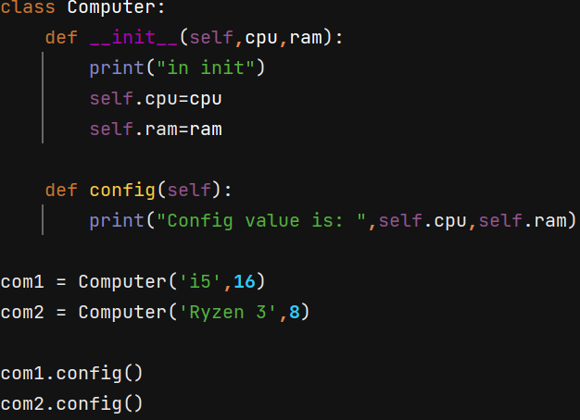

Once we instantiate Computer(), init is called twice as we have 2 objects & then 1st object config is printed followed by 2nd.

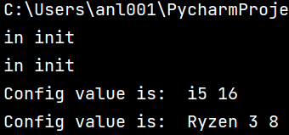

# Constructor, Self and Comparing Objects

A constructor is a unique function that gets called automatically when an object is created of a class. The main purpose of a constructor is to initialize or assign values to the data members of that class. It cannot return any value other than none

__init__ is actually a constuctor.

Whenever we create objects, it takes space in heap memory. Every space will have some address

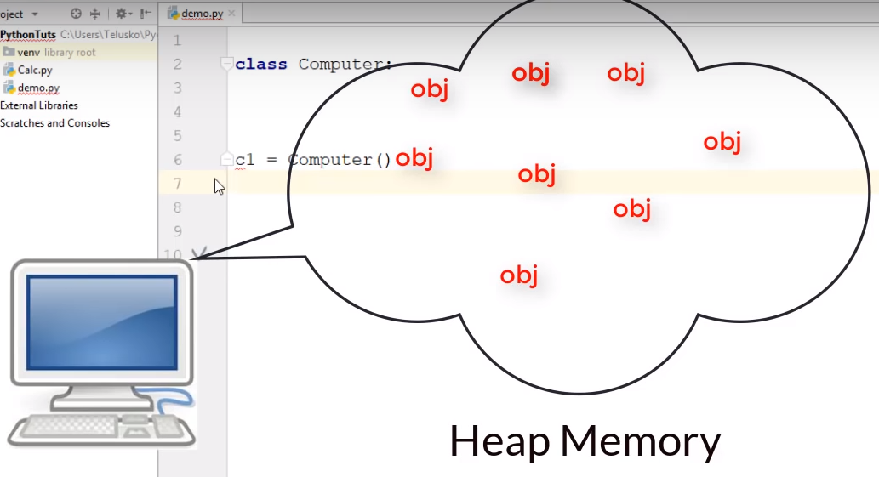

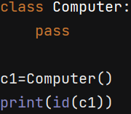 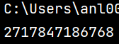

Size of the object depends on number of variables it has, how much data we pass. Who is responsible to calculate the memory is your constructor

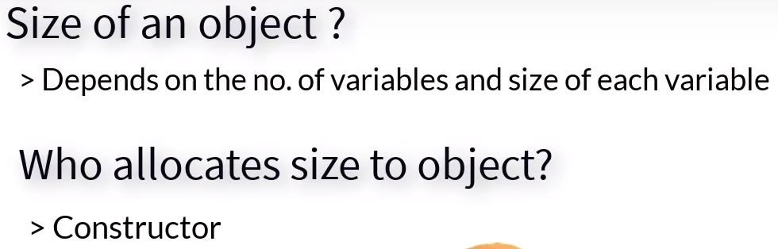

Constructor is nothing but Computer() present in the code which calls __init__ method by default. All our variables will be initialized in init.

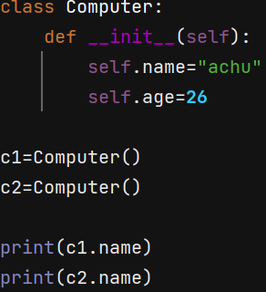 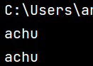

Both objects have same name because they are not initialized to any specific variable & are having the same value present in the class/design

We can also change the name of c1 by specifying it.

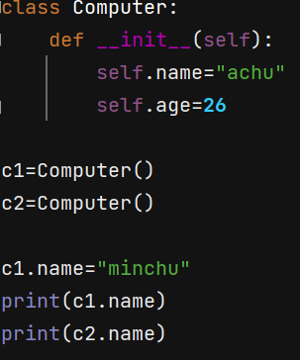 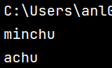

The question is why do we need self here. Lets say w ehave another method update()

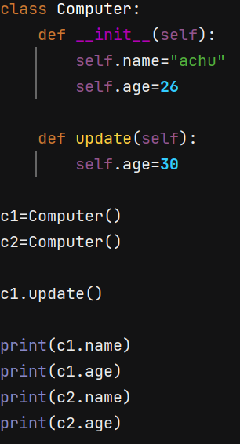 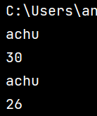

When you called c1.update() , the update function/method is hit and c1 age is modified here and while printing, c1 and c2 are taking same names as in init but c1 age is changed c2 age is same

When you try to compare 2 objects, python is not recognising this condition

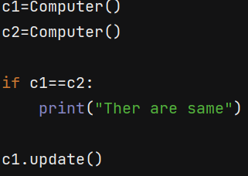 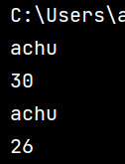

We need to build compare method and use it for comparing

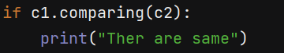

We need to define and build this compare. The line if c1.compare(c2) is assigning self=c1 and other=c2 in the compare() menthod we have created inside the class

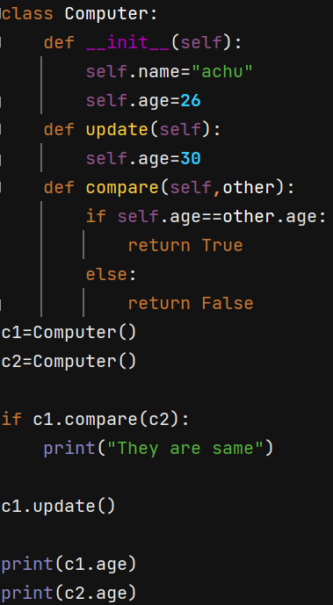 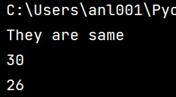

We can compare 2 objects by defining our own functions which is “compare” in this case

# Types of Variables

In Oops we have 2 types of variables:

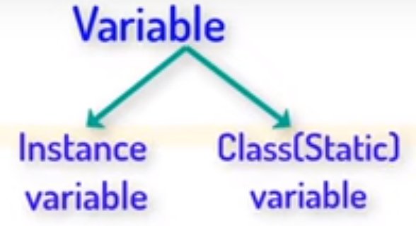

Lets take an example of car. Car has many attributes like name, engine, power etc. Attributes are different for different cars and the values of these attributes will be changed when we talk about another car. This is Instance variable (which can be changed) but what if we have the attribute which has same default value in all the cars? Such that changes in that attribute should change rest of the car’s THAT attribute.

If we define a variable inside __init__ it becomes Instance variable which can be changed. When you define a variable outside the __init__ but inside a class, it becomes CLASS variable.

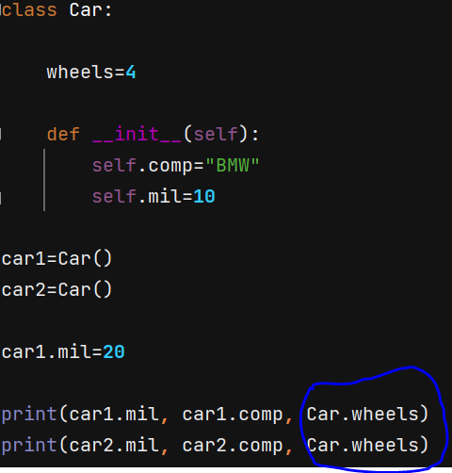

Here above mil and com are specific to that particular object but wheels can eb accessed by any object. We can use class name as well as object name to call wheels data as it is accessible anywhere inside the class and not restricted to a sppecific object

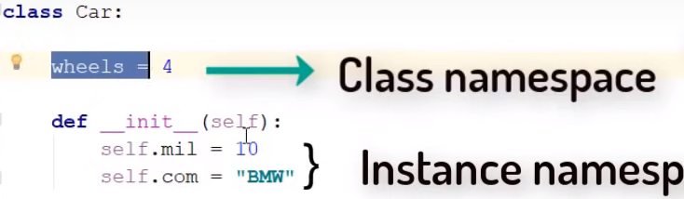

If you change the wheels for car1 only then it will affect the object car1 only like below

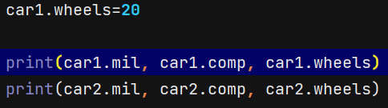 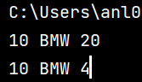

You can also change the class variable value like below and it changes the whole object values

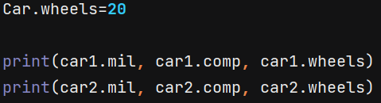 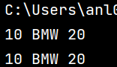

# Types of Methods

Methods are nothing but the behavior/action of an object and theer are 3 types:

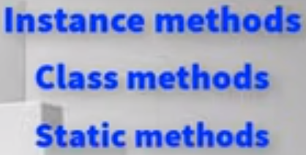

In Variables Class & Static are same but in methods they are different

The avg() method created below is the Instance type of method which accepts values that change based on user input

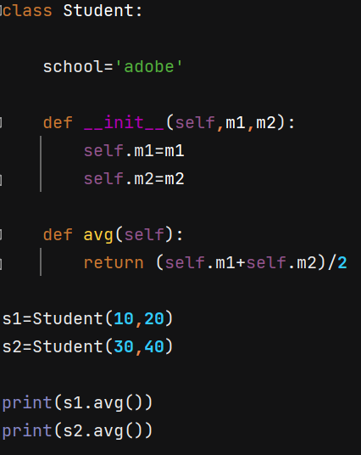 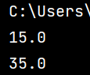

There are 2 types of Instance Methods:

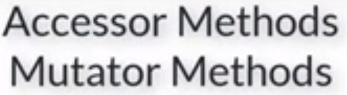

Accessor: used to just fetch the variable values

Mutator: used to modify the variable values

So if you want to get the value, you can just write Accessor Instance Method like below. Get is just a conventional name I have written for us to understand

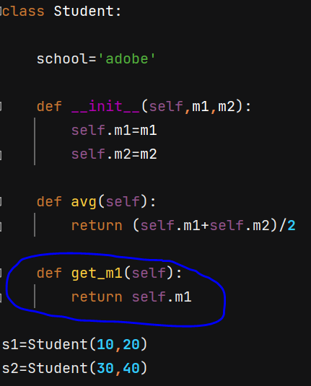

We can use constructors (like below) or just assign values like assigning to a variable s1.m1=10

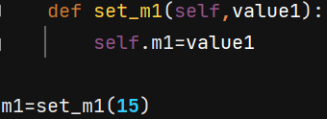

The above example is of Mutator Instance Methods

Getters are called Accessor Instance Methods & setters are called Mutator Instance Methods

m1, m2 are all instance variables which work with Instance mwthods. We also have a class variable “school” with which we have to work with Class method.

If you are working with Instance variable, we use self keyword & working with Class variables require class keyword like below

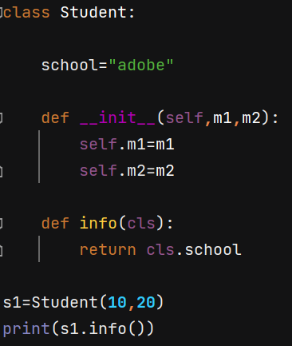 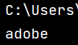

Above we are printing 1 student info, what if we print the class info, we get error

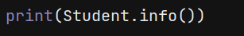

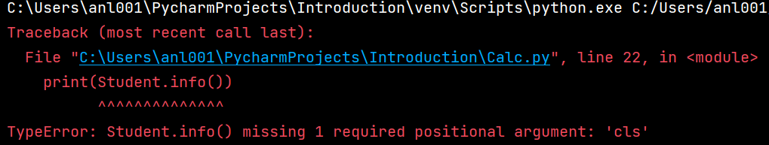

While creating class method, we need to use a special symbol ***@classmethod*** or something called decorators.

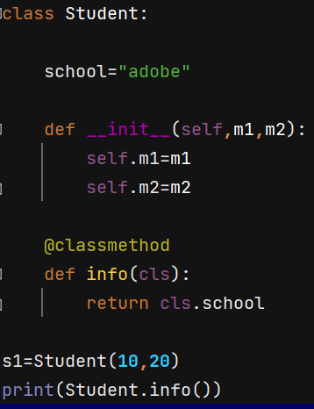 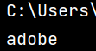

Static Methods: when we have nothing to do with instance variables or class variables, when we have to do something different which is not concenred about the variables, we use static method.

When you have something to do with other objects but not with the objects there in our project, we can use static method and we need to pass special keyword **@staticmethod and no need to pass any argument like self or cls, just leave blank**

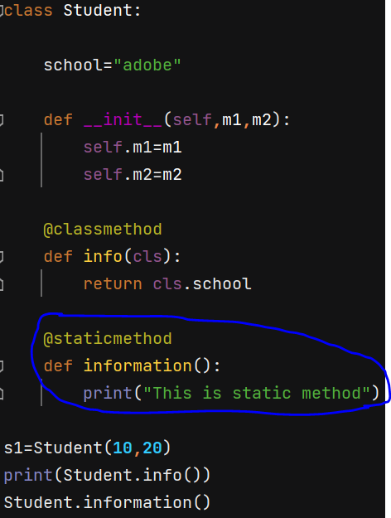 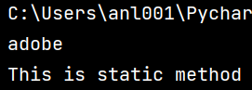

# Inner Class

Can we have a class inside a class?

Yes, inside of creating a class outside and then using it somewhere, we can call a class inside a class.

**Class Student is OUTER CLASS and class Laptop is INNER CLASS**

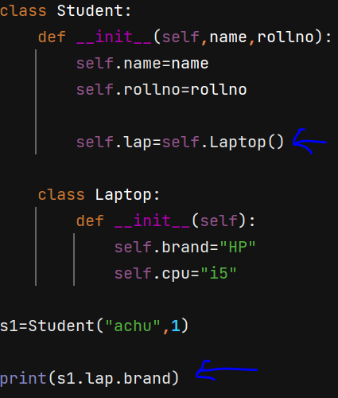 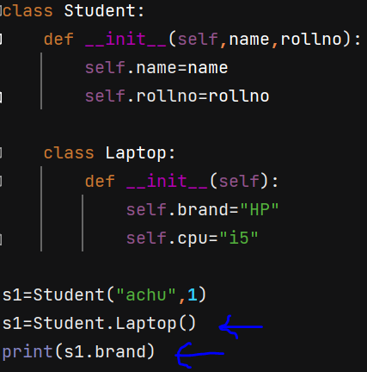

Once we create class inside class, we can create its object inside the outer class. In the constructor itself you can define a variable. In the outer class we can define the object.

Whenever you want to call brand name, you just cannot call only Laptop class. We need to call the object also as the Lap object is inside the class.

**You can create object of inner class inside the outer class as in above 1st snap (provided you need to assigb this object to outer class variable) OR You can create object of inner class outside the outer class (provided you use outer class name to call it)**

You can have 2 show() methods and interlink one another like below

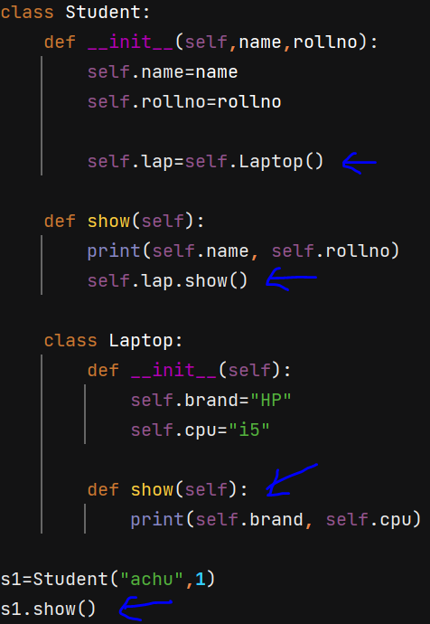 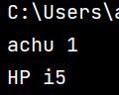

# Inheritance

Process of using the features of existing class. Inheritance allows us to define a class that inherits all the methods and properties from another class. Parent class is the class being inherited from, also called base class. Child class is the class that inherits from another class, also called derived class.

All the languages that follow Oops concept, they do implement inheritance.

Example: Your dad’s phone is your phone and your phone is also your phone.

Class can inherit a class

Lets say we want class A features along with some extra features that is in class B. Instead of redefining the class, we can make use of inheritance and get the extra features

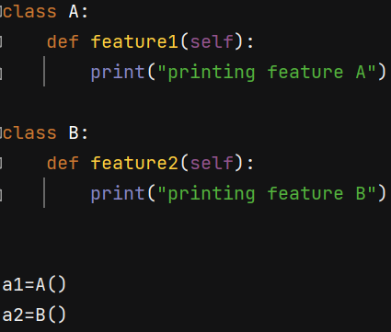

Above, if you want feature 2, you need to access class B and for feature 1, you need to access class A. What if you want class A features in class B? You can inherit like below

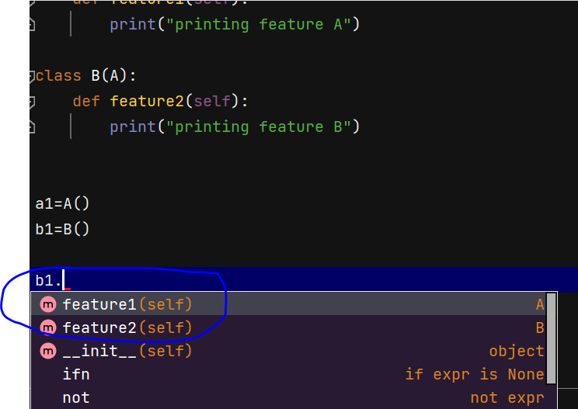

Now above you can see, b1 will have access feature 1 of class A.

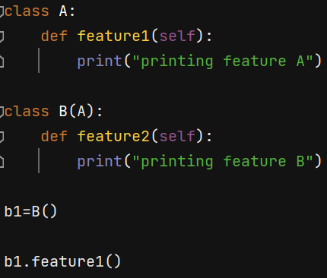 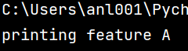

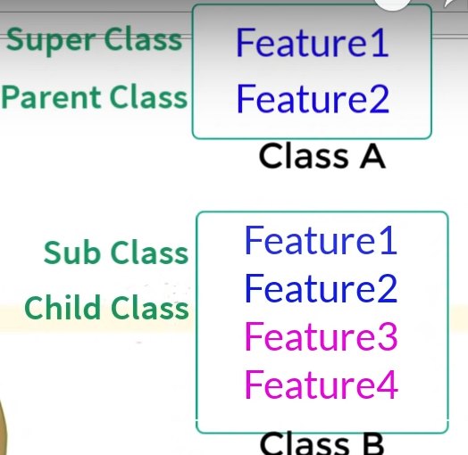

Single level inheritance

* Class A:
* Class B (A):

Multi level inheritance

* Class A:
* Class B (A):
* Class C (B):

Multiple level inheritance

* Class A:
* Class B:
* Class C (A,B):

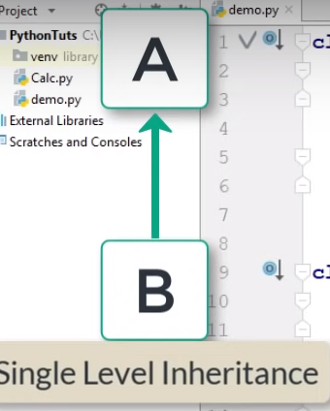 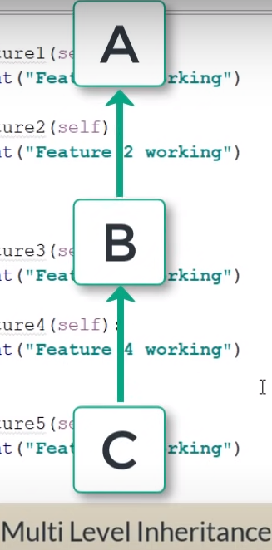 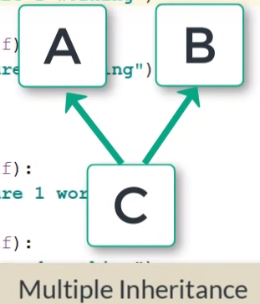

# Constructor in Inheritance

When we have constructor in parent class and you are calling an object that inherits this parent class, will it inherit the init as well of the parent class? Let’s see this

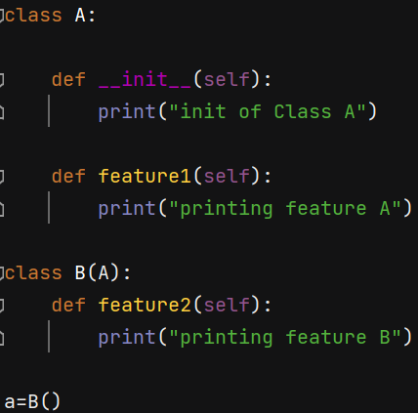 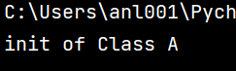

Just because Class B doesn’t own any constructor but makes use of the one present in the parent class A, we are getting the constructor feature from the parent class. What if B class has its own constructor? Class A constructor is not used as B has its own.

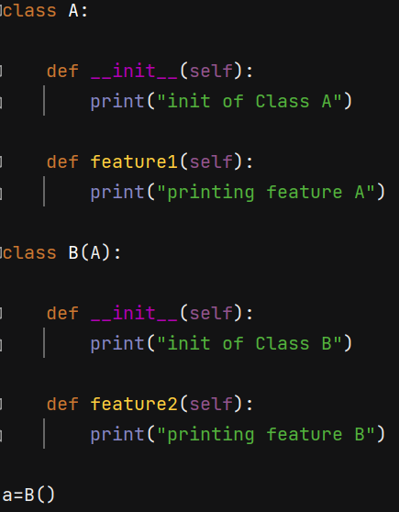 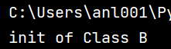

**NOTE**: If you create object of subclass, it will 1st try to find init of subclass. When not found, it will then call init of parent/super class.

What if you want to call init of parent class as well? We can do with the help of the method “super().__init__” . The moment we say super, we are representing the super class.

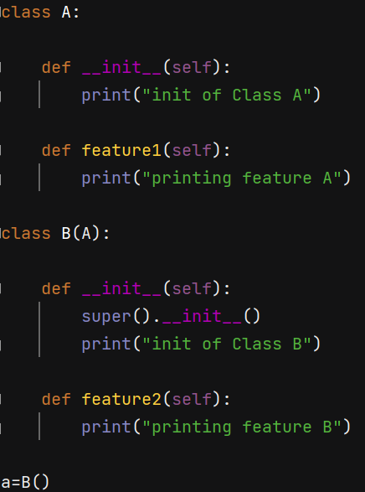 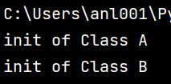

**NOTE**: When you create object of subclass, it will call init of sub class 1st If you have called the super method, it will 1st call init of super class and then calls init of sub class.

The functionality remains same even in the multiple level inheritance except for superclass

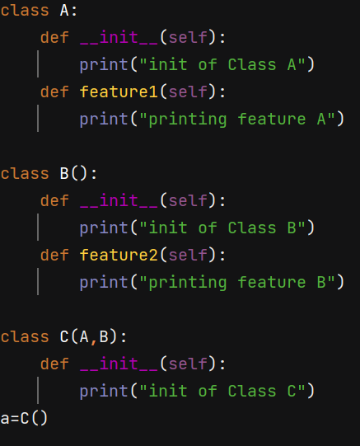 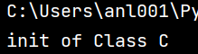

While inheriting the constructor of superclass there is a twist

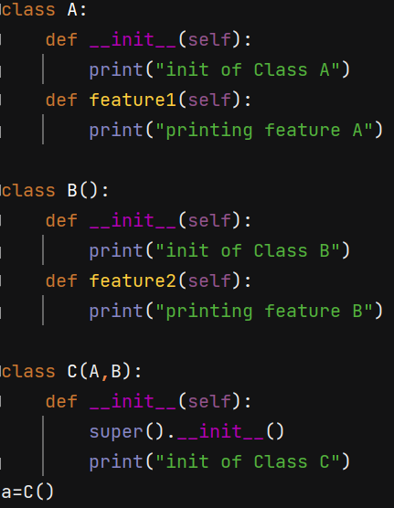 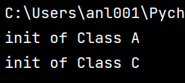

Above if you define class C as Class C(B,A) then it inherits Class B constructor and class C but not A which is not fair.

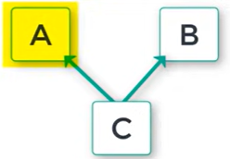 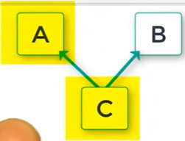

We have a concept called Method Resolution Order (MRO). Whenever we have multiple level inheritance, it starts from left to right.

Another example with function feature 1 that is present in both the class A & B

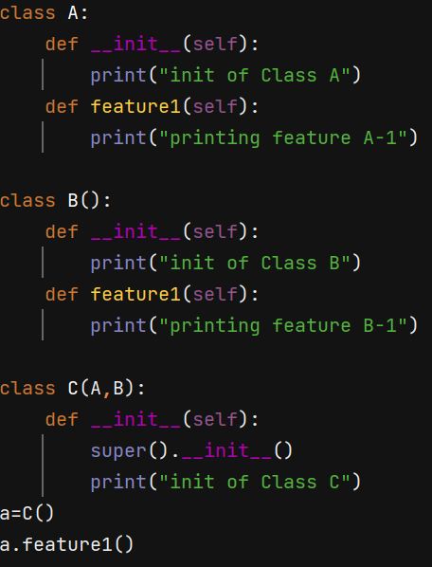 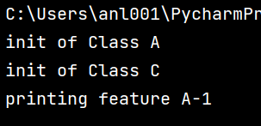

We can also make use of super class methods/functions like below

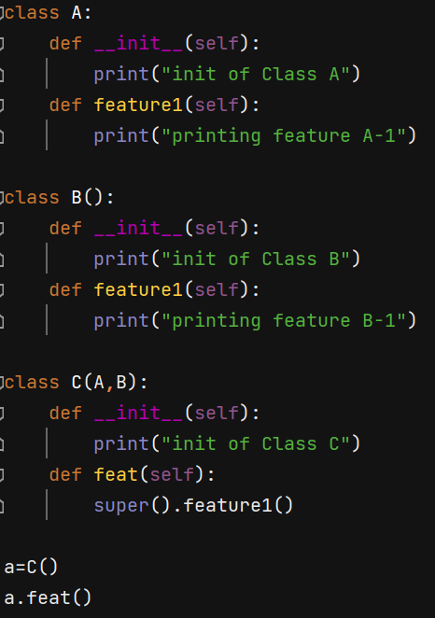 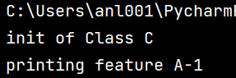

# Introduction to Polymorphism

As human, we have different forms. As situation changes, we behave differently. We are polymorphic.

Similarly, an object has many forms. Polymorphism is nothing but 1 thing in different forms.

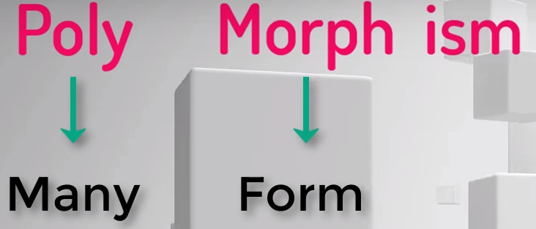

There are 4 ways to implement polymorphism in python: Duck typing, Operator overloading, Method overloading & Method overriding.

In java or C, you will have to mention the type of object or variable you work with but in python it is different which we see in below topics.

# Duck Typing

If you see an animal which quacks and swims, doesn’t matter what its name is, we call it a duck right. We have a concept called Dynamic Typing in python. Means we can mention the type later & no need to mention while assigning. We can assign 2 different values to a variable.

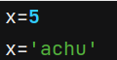

Here above, we are not changing the type of x, it is just that 5 has a memory of type integer and achu has a different memory of type string. X is just a name to these.

Let me create a class and a method & pass IDE as argument assuming someone will pass IDE to us. Then let’s use this IDE and perform something like below

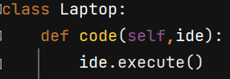

The question is what type is this IDE & execute is something that we haven’t defined in our code

The IDE type is something unique and user is defining. If you want to create an object IDE, you need to create a class

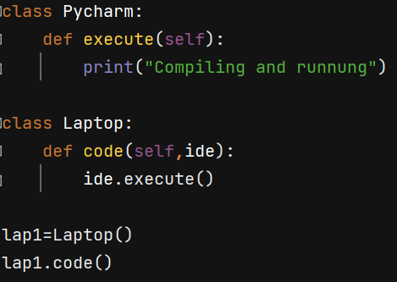

And now inside lap1.code() we need to pass an IDE

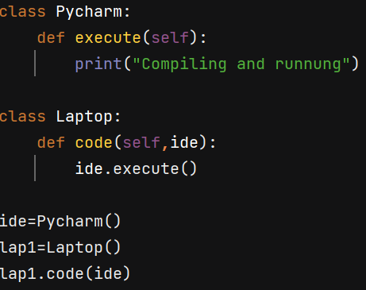

Here the type of IDE is PyCharm. Is it fixed? Can we change the type? Let’s say we have 1 more IDE

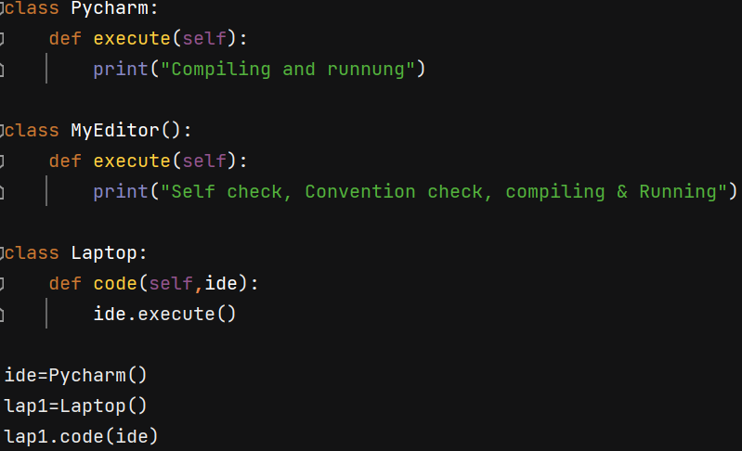

And when we want to change the type of IDE as per our convenience, we can replace the IDE type from PyCharm to MyEditor provided that we have the method execute(). It shouldn’t matter which class Object your are passing but it matters that object should have the method execute.

So change the line ide=Pycharm() to ide=MyEditor() and see the output. The code will still work but with different output depending on the characteristics of that IDE.

So, if a bird acts like a duck, swims, quacks like a duck, it should be a duck. The same way, if there is an object IDE which has a method execute, that’s it. Do not be concerned about which class object it is, the concern is it should have the method execute. This is duck typing. This is like “Interface” topic in java.

# Operator overloading | Polymorphism

Operators are not but the signs we use to perform any kind of operation like + - * etc.

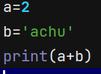 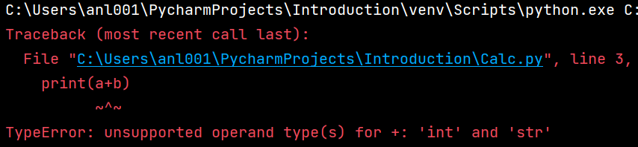

Here in the above error, we can see, these things are predefined saying int and str cannot be used at once with this operand. These predefined things like are called as “**Synthetic Sugar**” simply means it is simplifying the code for the user.

Behind the scenes things are different and whatever happens in python, happens with objects. Similarly, this “int” is a predefined class. Class with have methods.

int.__add__ (a, b) is a method which adds 2 numbers passed as a and b

So, both the line of the below code gives same output

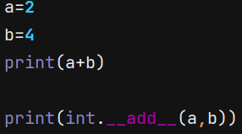

a+b is something we did from childhood but whatever we do in program, we do it with methods.

“int” is an inbuilt class and “add” is a method inside it due to which the statement will perform addition

If you click on that “int” in the PyCharm, you get the notes like below

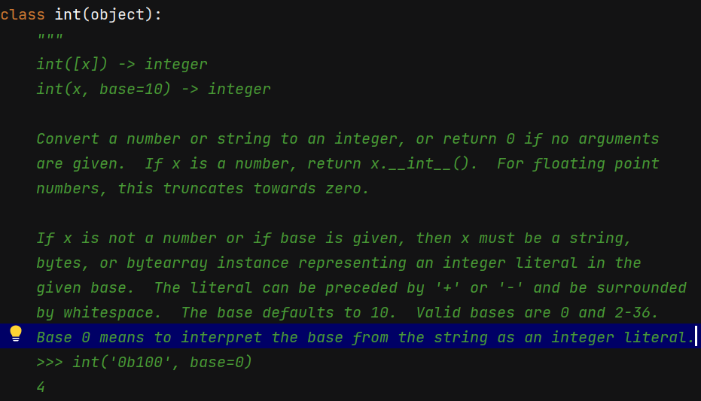

Also there are some methods defined inside this class like below

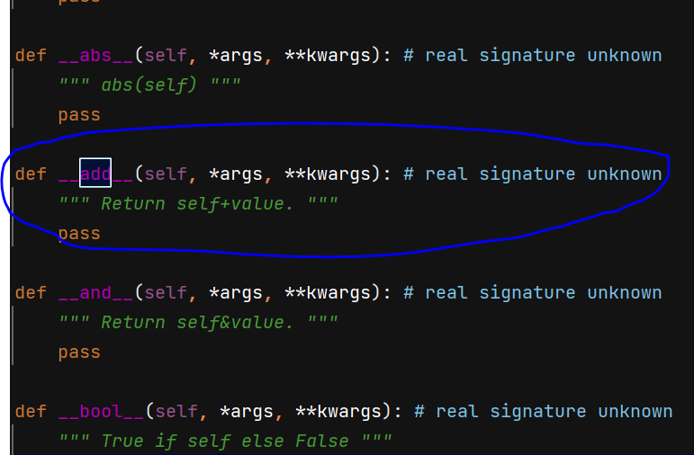

So, whenever we are adding 2 numbers, this is what is getting called in the behind.

If I add 2 strings, then I should change the class from ‘int’ to ‘str’ like below

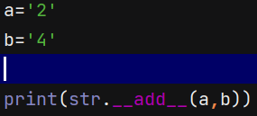 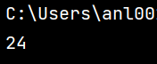

We have different methods for different operators. When you say + it calls add method, similar sub method for -, mul method for *. **Normally these are called Magic methods. All these operators behind the scenes they work as Methods.**

If I create a code and try to add 2 marks, lets see how we can do that

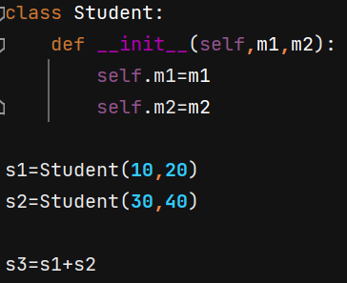

We get the error saying unsupported operand type + for Student

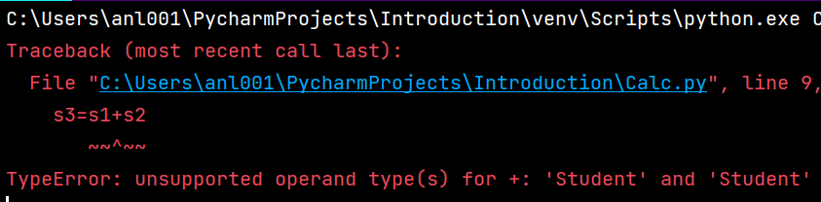

It means, the Class “Student” *is not supporting this operand. So, we need to add this method inside the class “Student”. **So, you can overload this operator with the method you create in the code like below**

Behind the scenes when we use +, it is calling add method. But what to add is not mentioned properly.

Integer knows what is +, string knows what is +, but student class doesn’t know right so we need to overload this operand + for this class as per our requirement.

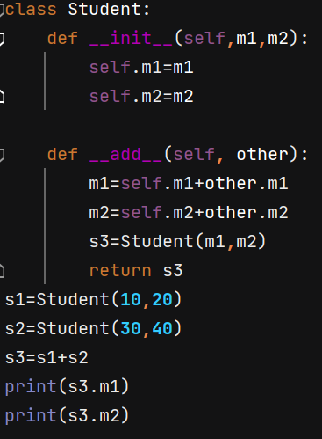 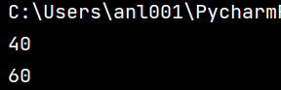

To compare 2 students marks, instead of writing logic, you can make use of inbuilt method “gt”. The simple code like below calls “gt” in the background and gives output like below

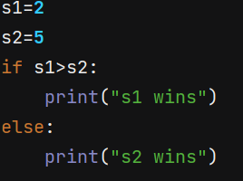 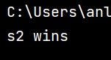

Now we are overloading this “gt” in our below code as per the requirement

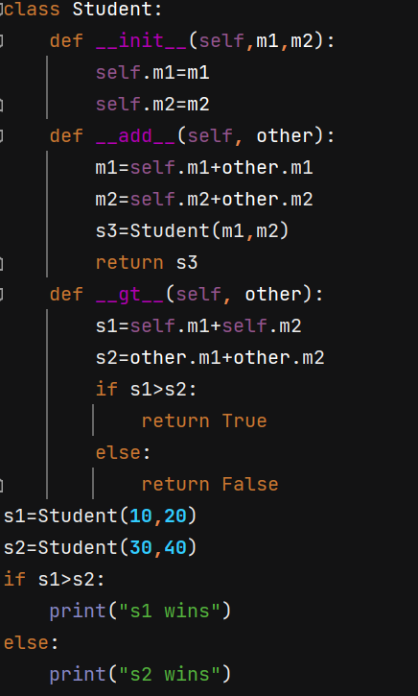 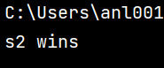

I modified the above code like below

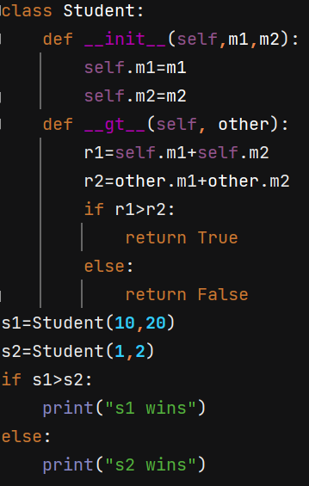 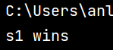

And then along the same code, it will print the value of a but when it comes to s1, it prints its address. This is because behind the scenes, when you try to print some variable, it calls ‘str’ method behind.

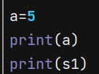

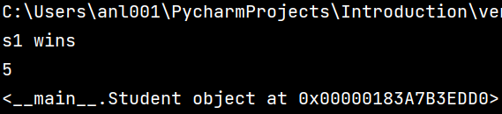

So, let’s check by using this str method in our code

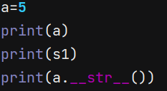 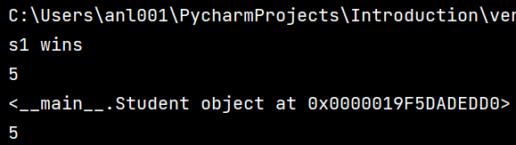

Now I need to overwrite this method for my use.

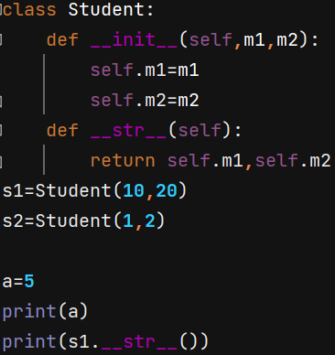 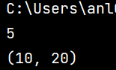

But when you call s1 alone thinking you have overwritten the method, you get error

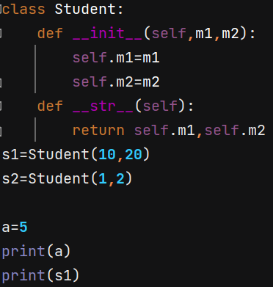 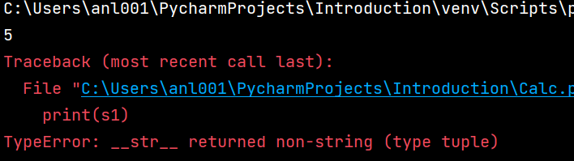

The error means it is returning the non-string value that is tuple which is (10,20).

Let’s edit the code to return str value. **return ‘{} {}’. format(a,b)** is the syntax

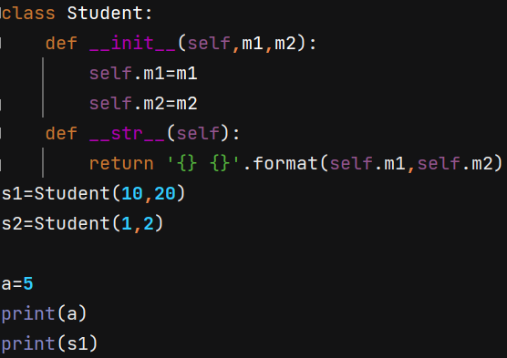 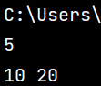

NOTE:

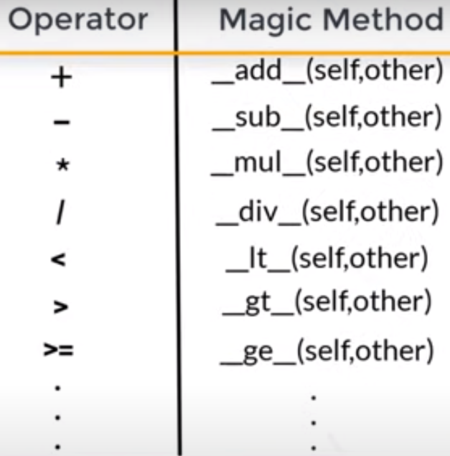

# Method Overloading & Overriding

In other languages like Java, we have Method overloading which is not in python.

Method Overloading: